Western Mathematics Exams

Half Yearly Examination

2015
Year 10
Mathematics Course

Solutions
Year 10 |  | WME Half Yearly Maths | Non Calculator
Section 1 Short Answer Section
ANSWERS
No. | WORKING |  | ANSWER
 | 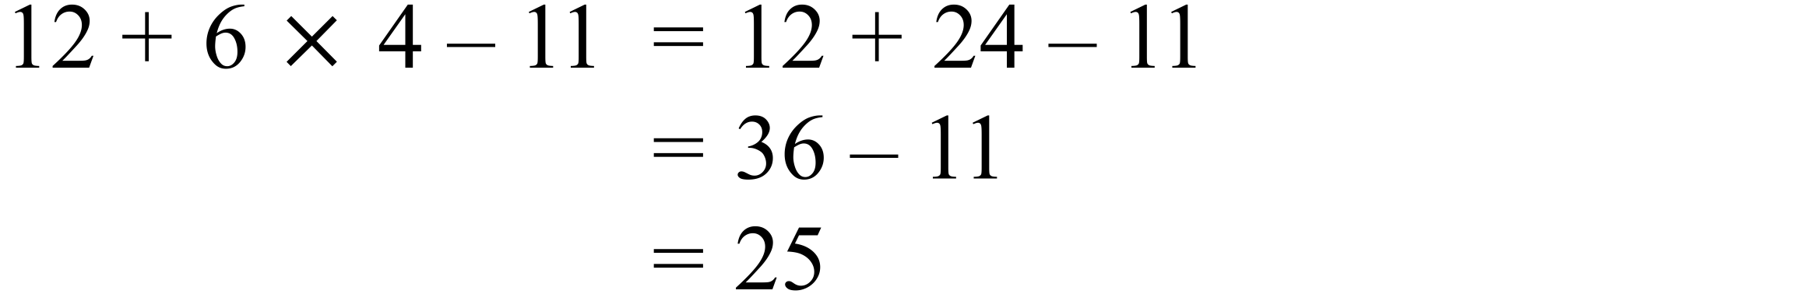 |  | 25
 | 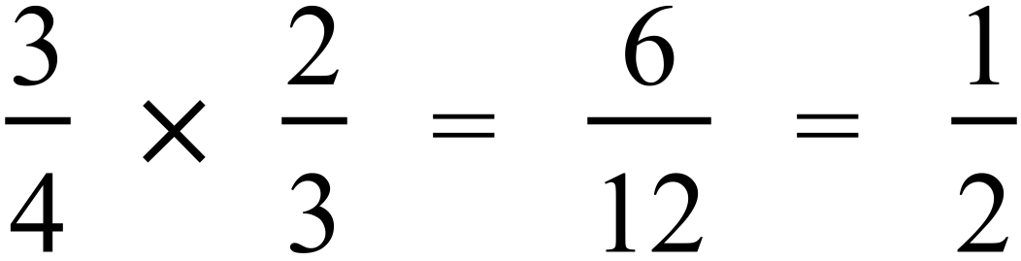 |  | 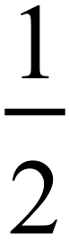
 | 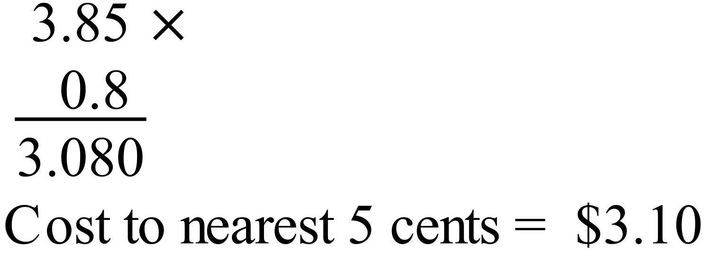 |  | 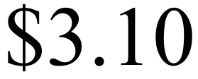
 | 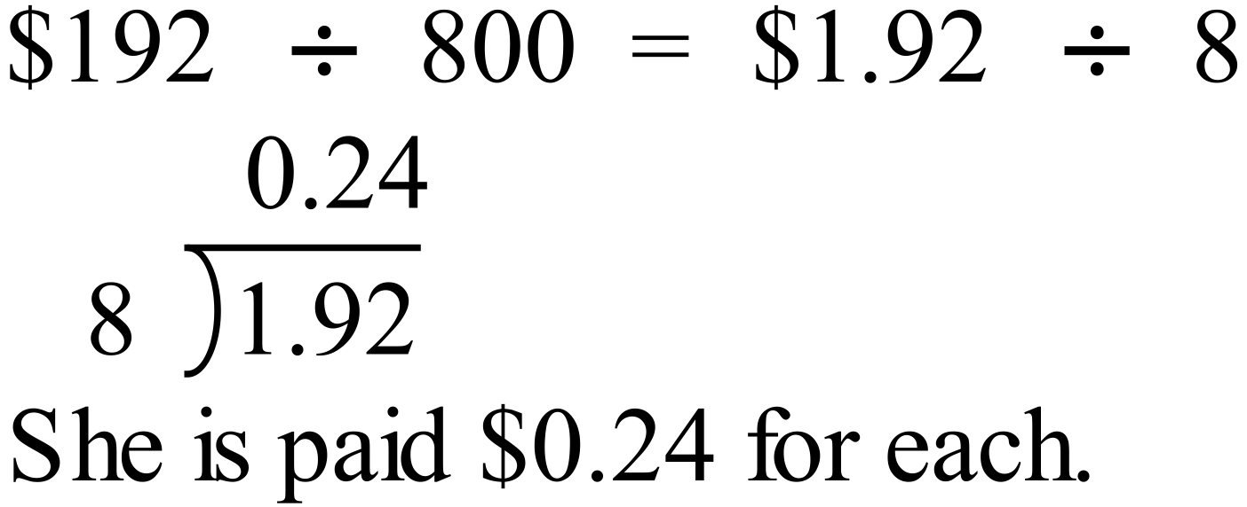 |  | $0.24
 | 30% discount leaves 70% to pay.  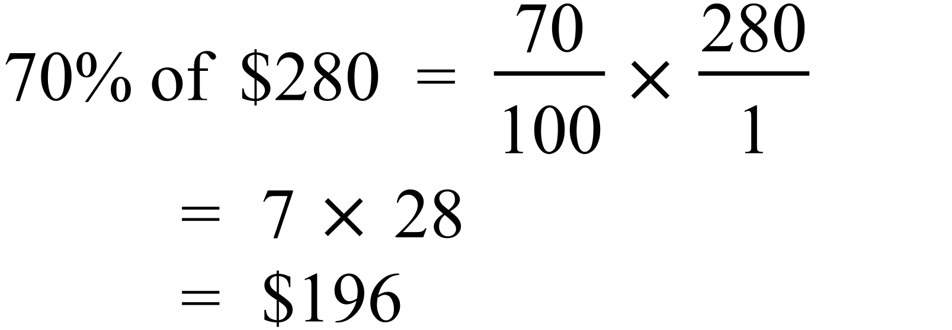 |  | $196
 | 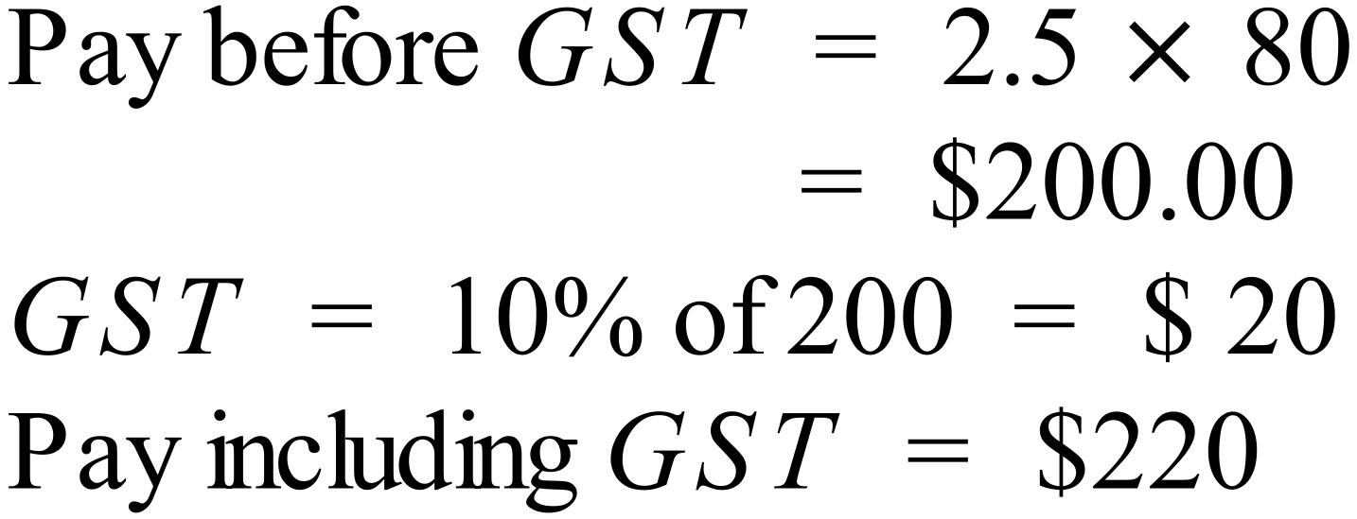 |  | $220
 | 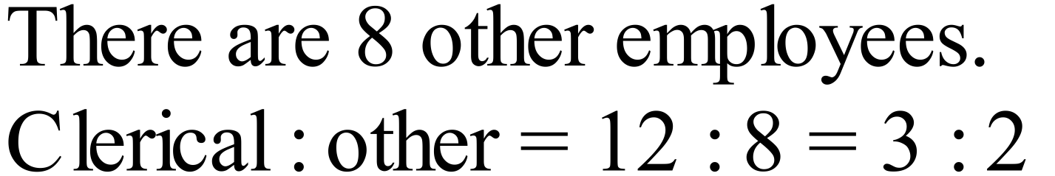 |  | 3 : 2
 | 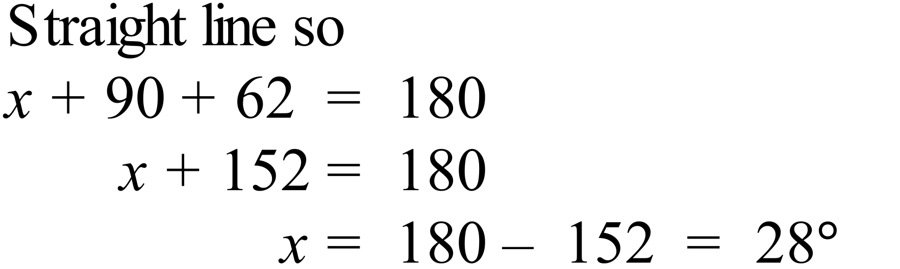 |  | 28º
 | Let third angle = 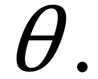  Using angle sum,  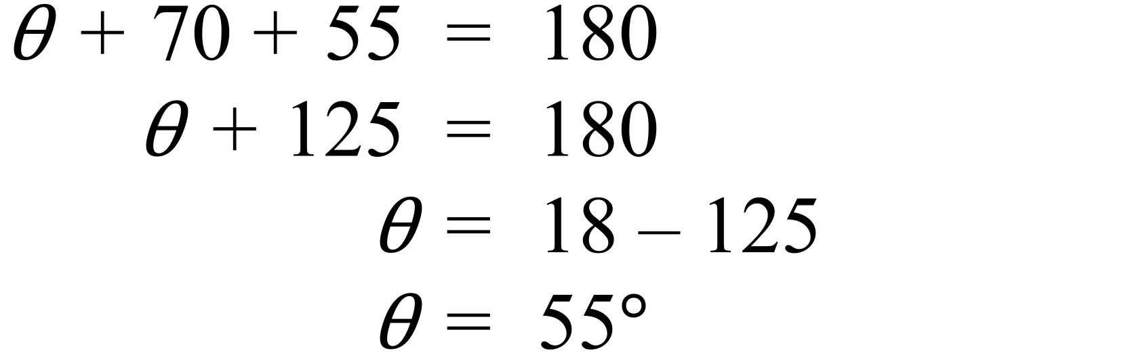  So angles are 55º, 55º and 70º  Triangle is isosceles and acute. |  | isosceles and acute.
 | 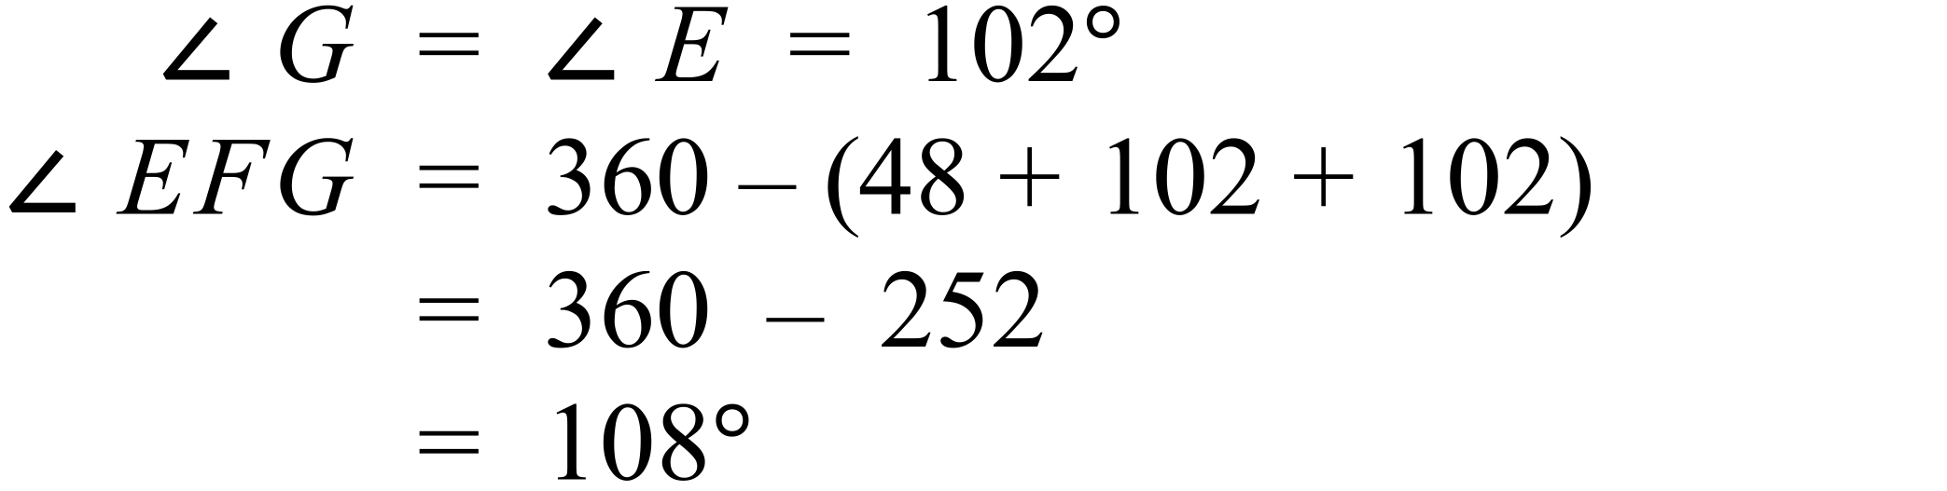 |  | 108º
 | 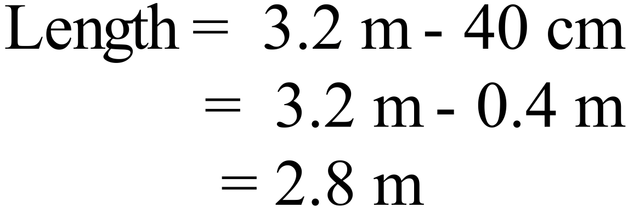 |  | 2.8 m
 | 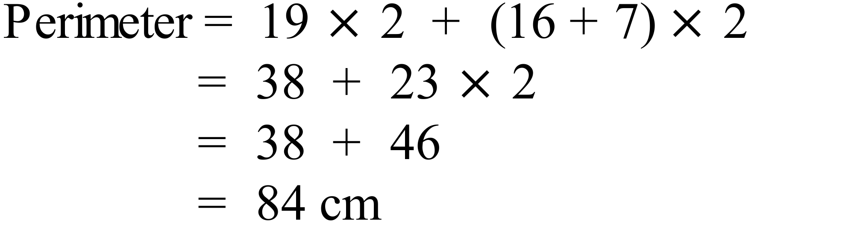 |  | 84 cm
 | The 22 cm base and 60 cm height are perpendicular.  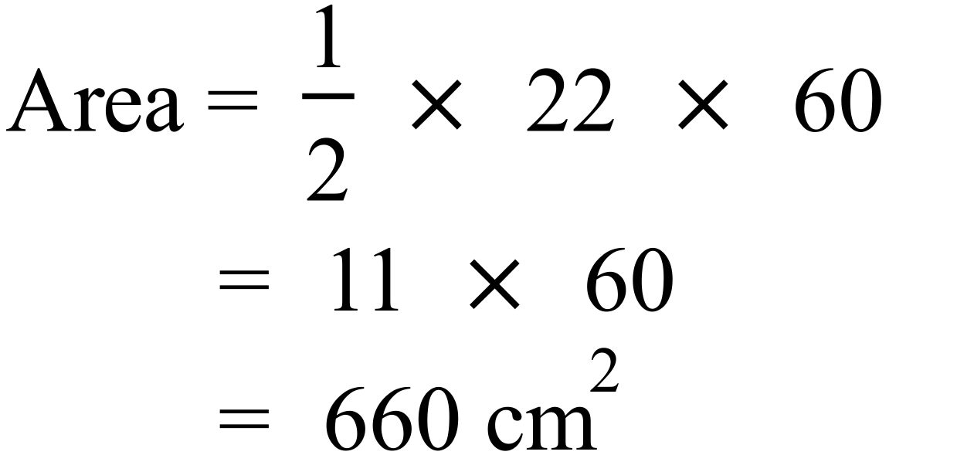 |  | 660 cm²
 | 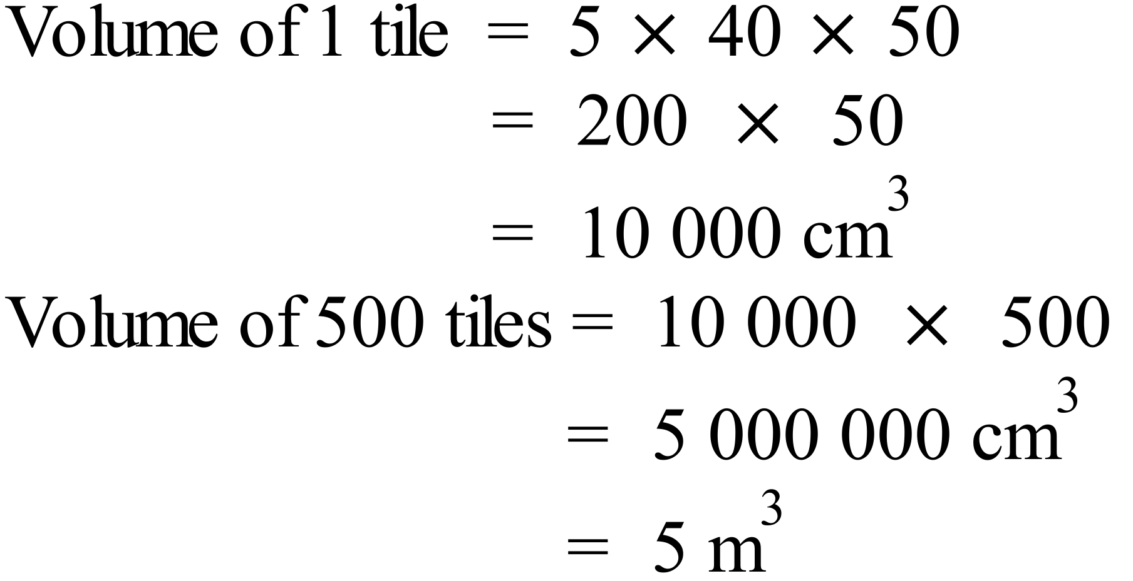 |  | 5 m³
 | Distance through W = 60 + 80 = 140 m  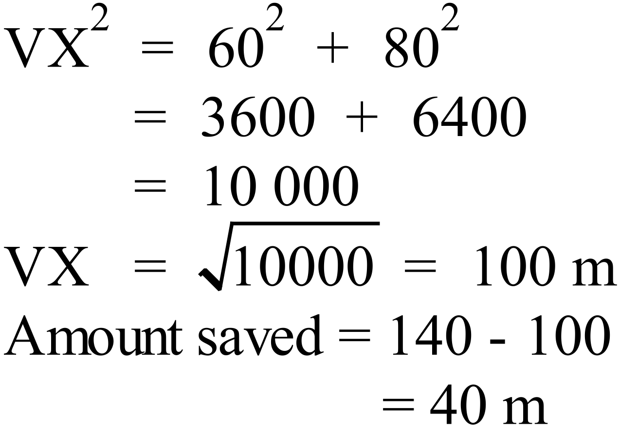 |  | 40 m
 |  |  | ab + 15a
 | 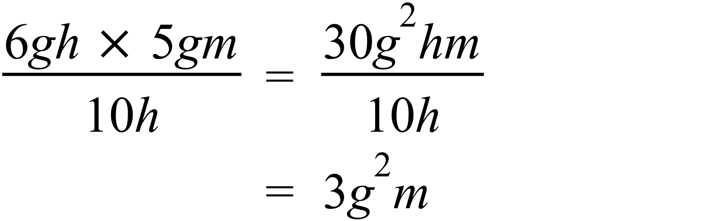 |  | 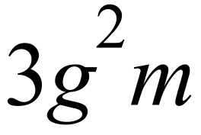
 |  |  | 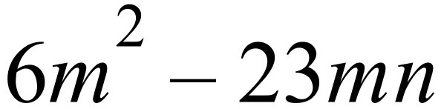
 | 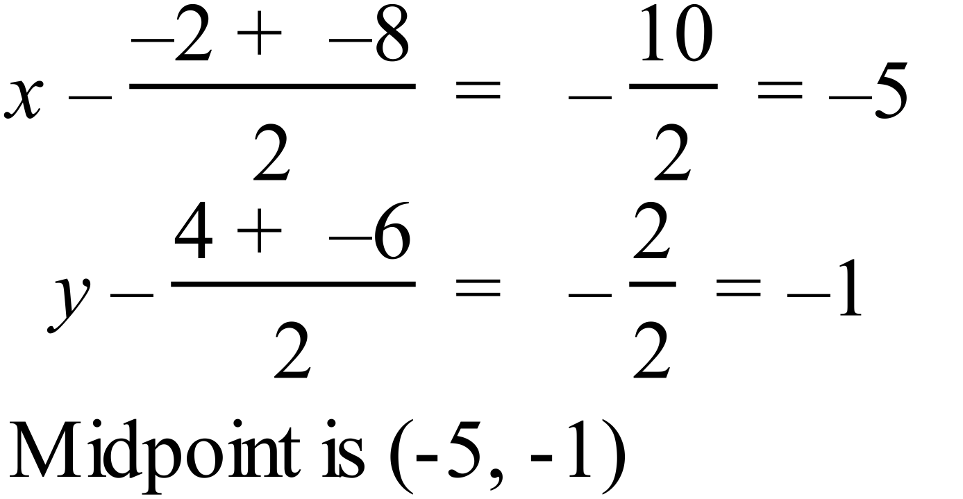  Or by using the number plane diagram. |  | 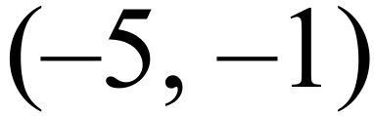
 | 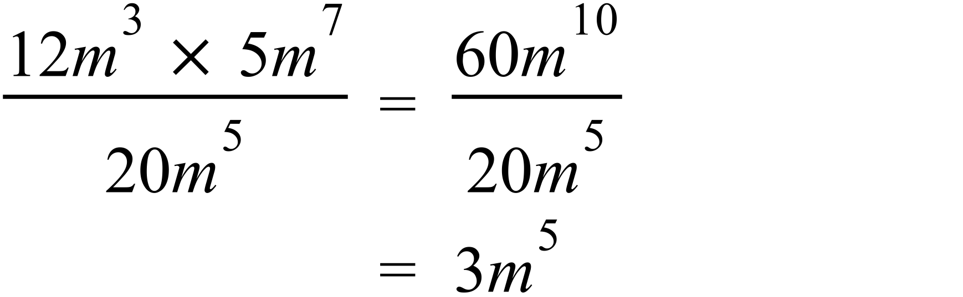 |  | 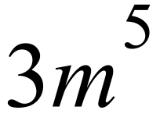
 | 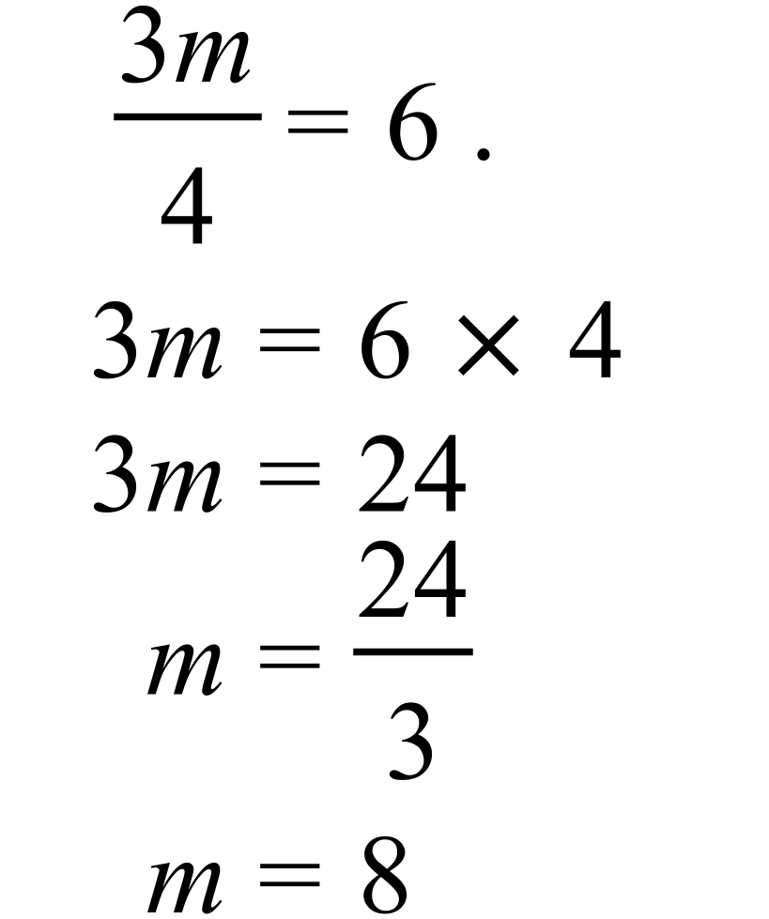 |  | m = 8
 | Number of marbles = 19 + 16 + 5 = 40  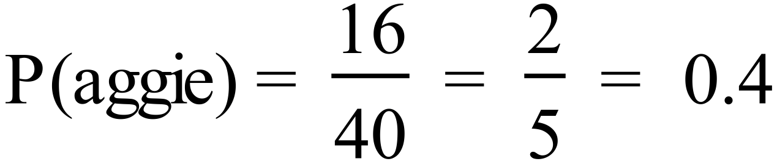 |  | 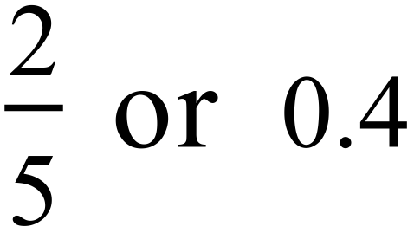
 | Arrange in order.  0.87, 0.95, 1.24, 1.32, 1.35, 1.45, 1.65, 1.75, 1.84, 1.88.  Middle two of 10 are 1.35 and 1.45.  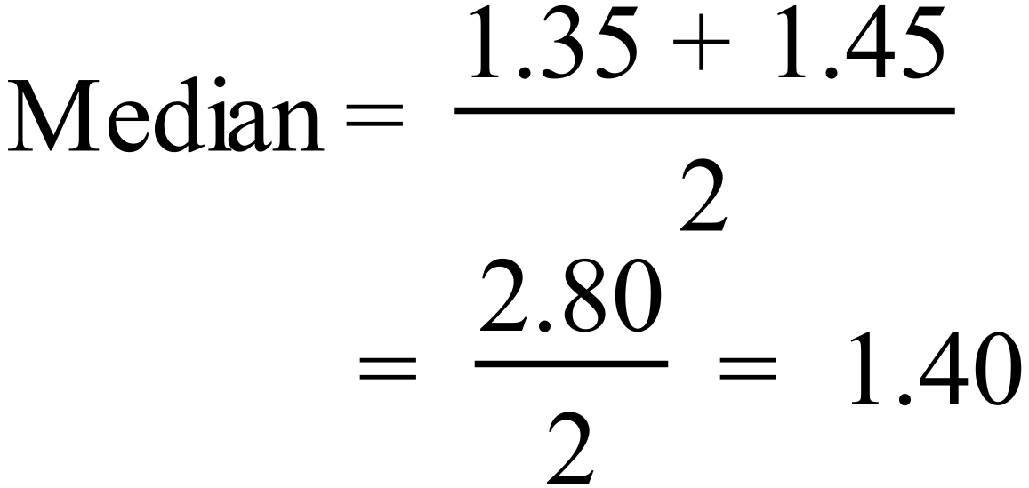 |  | 1.40 m
 | Between 1985 and 1987 the increase was $1 600 which was the biggest. |  | 1985 and 1987
 | Current record is 6.0 (in 2003)  Increase of 10% = 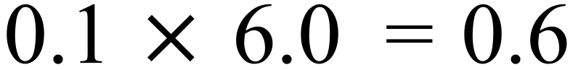  So need to make 6.6  In 2015 profit was 5.2, so increase compared to 2015 is  6.6 – 5.2 = 1.4 so $1 400. |  | $1 400

Year 10 |  | WME Half Yearly Maths | Calculator Allowed
Section 2 Part A Multiple Choice Section
ANSWERS
No. | WORKING |  |  | ANSWER
 | 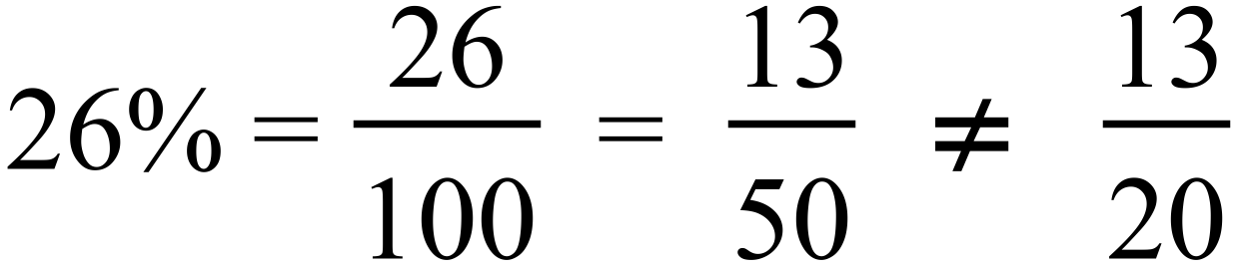  The rest are equal. |  |  | B
 | 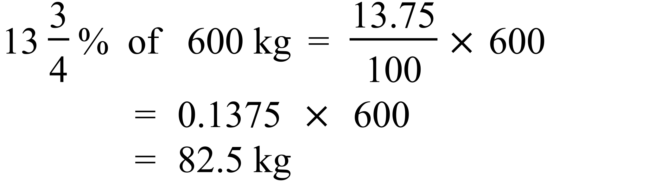 |  |  | D
 | 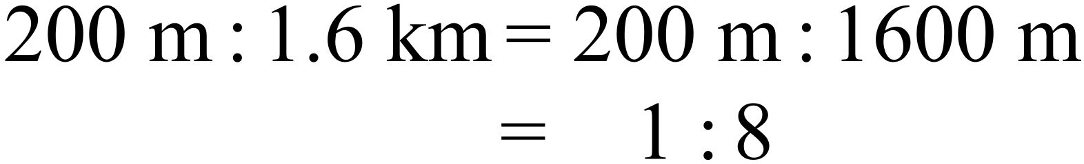 |  |  | C
 | 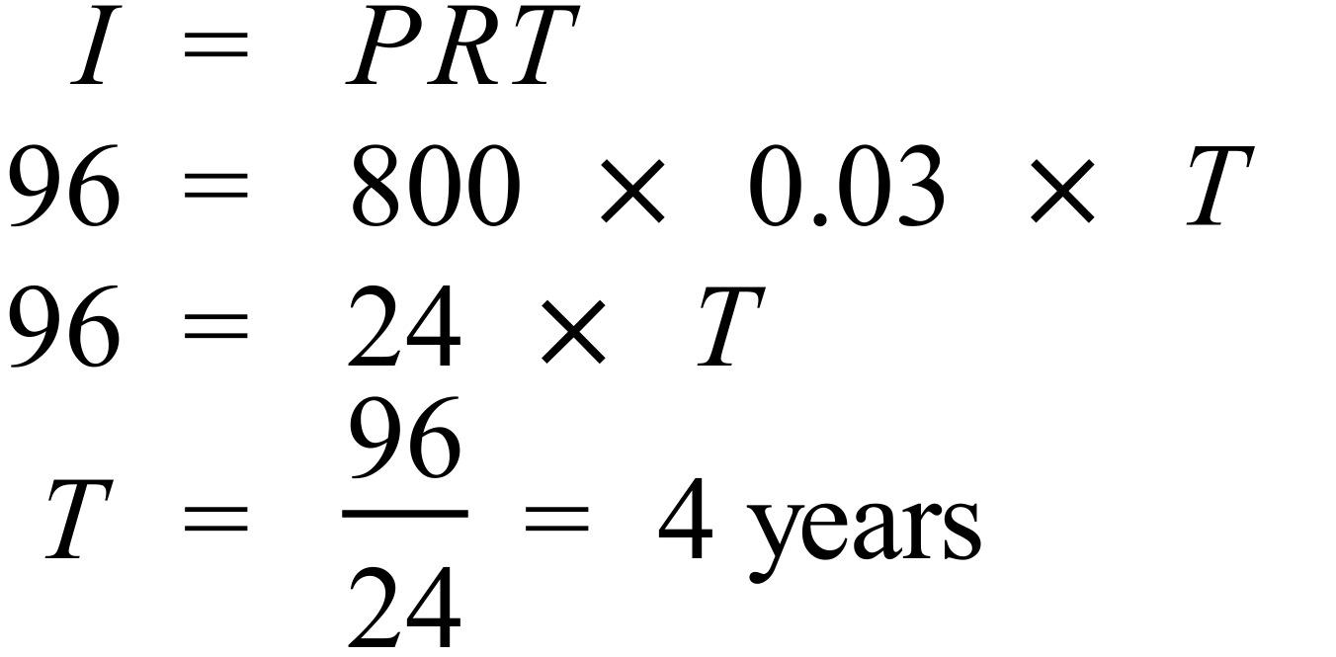 |  |  | A
 | 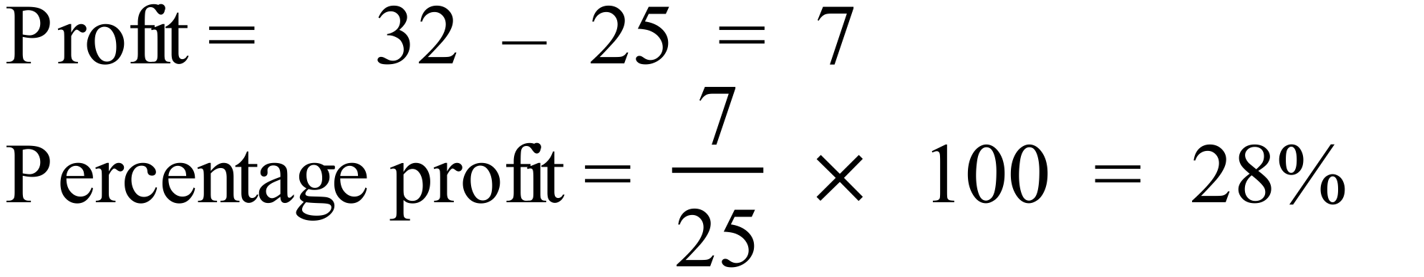 |  |  | B
 | 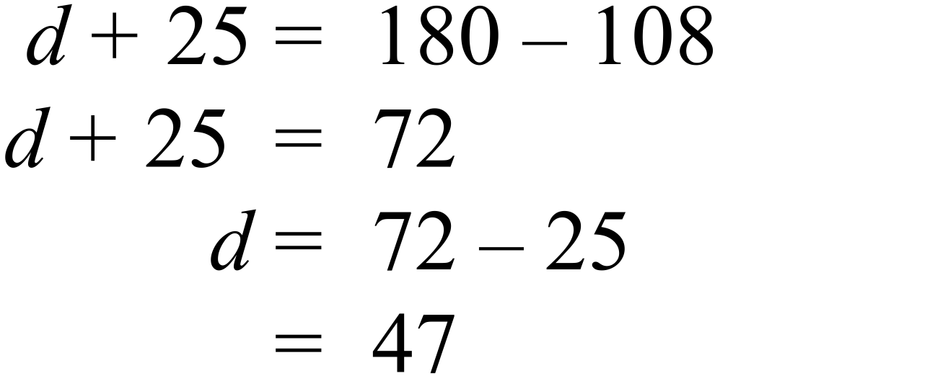 |  |  | A
 | A is not regular  B is non convex  C is not an octagon  D is a convex regular octagon. |  |  | D
 | A and B are reflections  C is a rotation through 180º  D is a rotation through 90º |  |  | C
 | 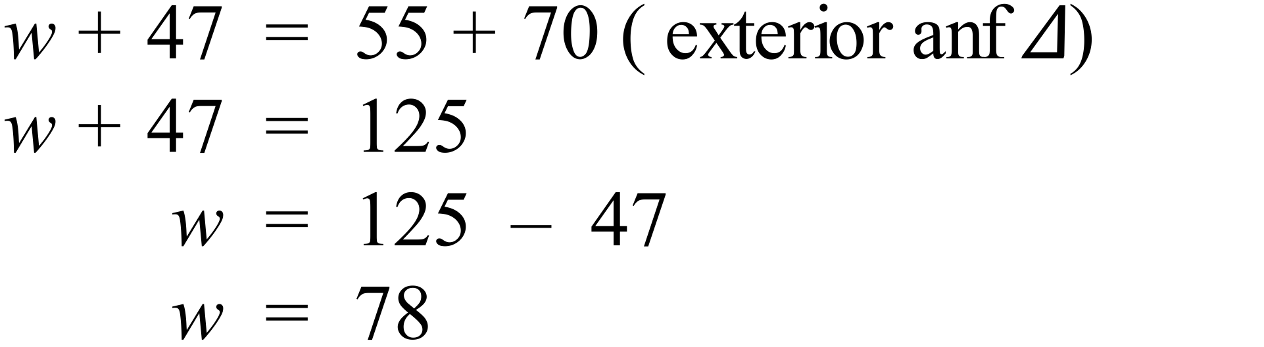 |  |  | B
 | Given that AB | | DC and BC | | AD, the quadrilateral is a parallelogram, so the diagonals bisect one another.  So AC bisects BD. |  |  | A
 | Rhombus  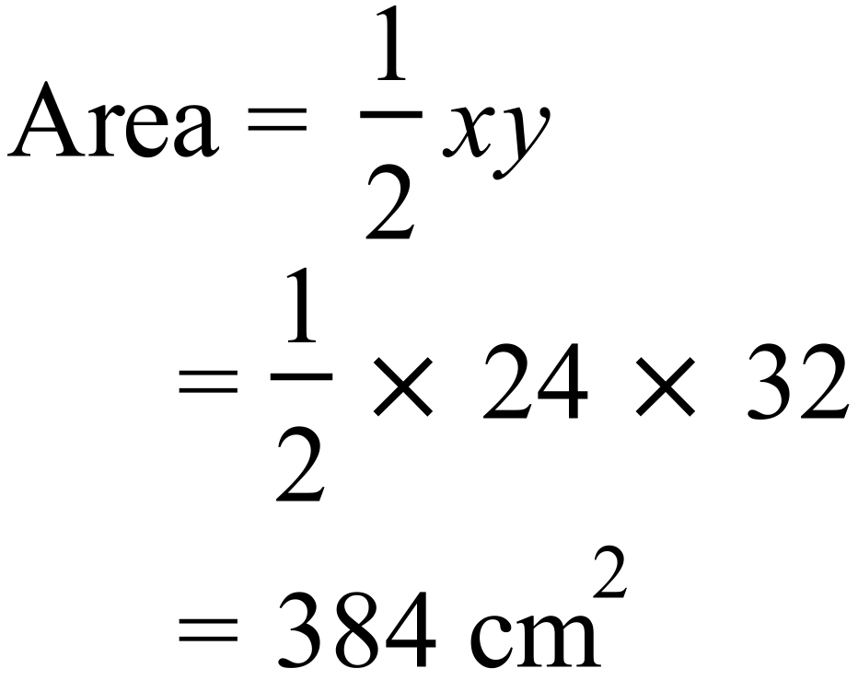 |  |  | C
 | 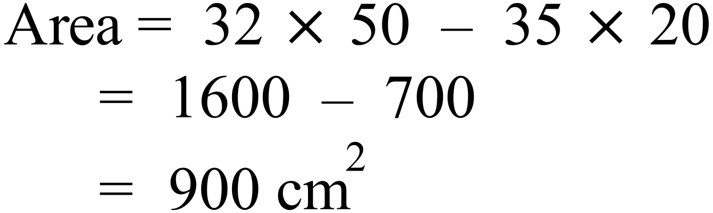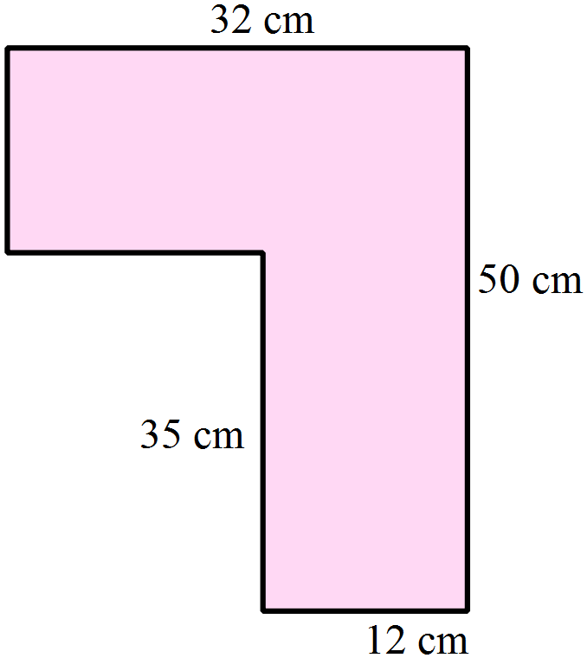 |  |  | A
 | 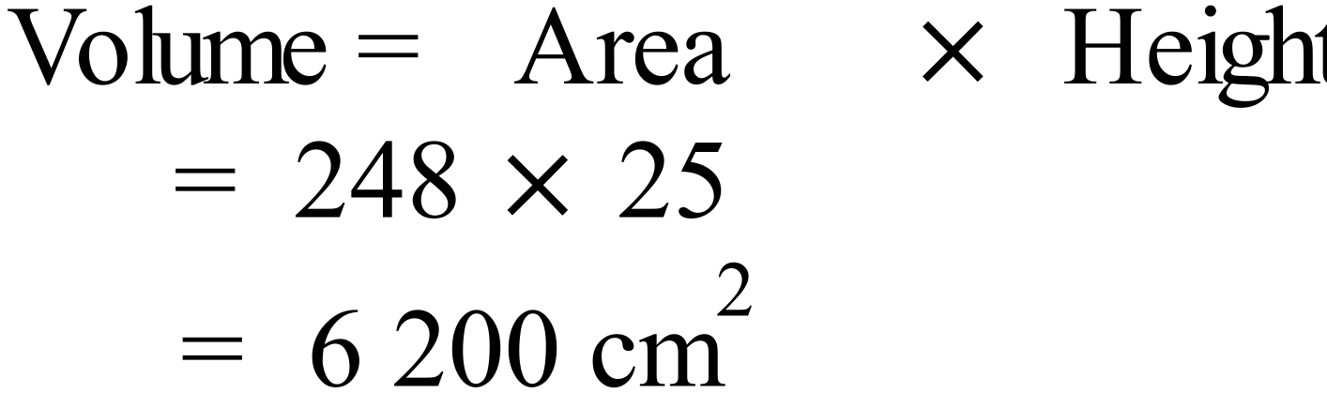 |  |  | B
 | 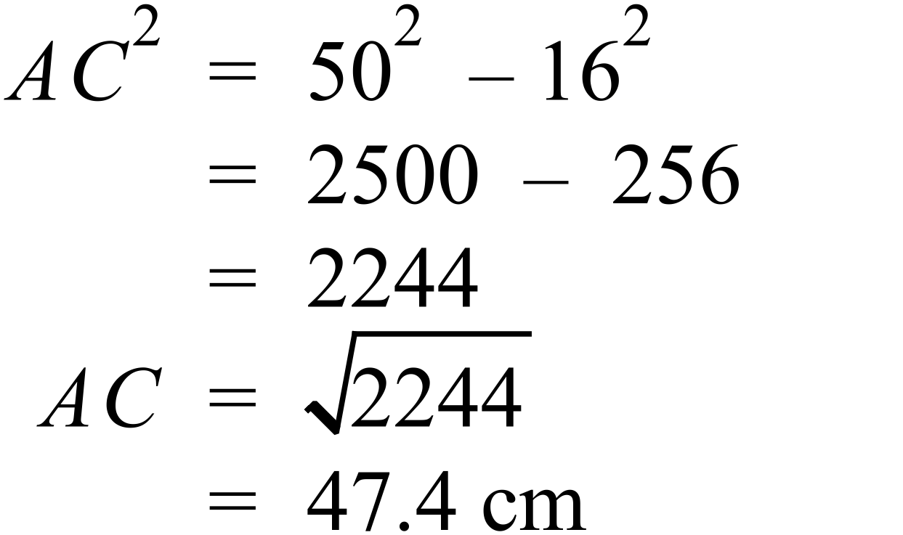 |  |  | B
 | 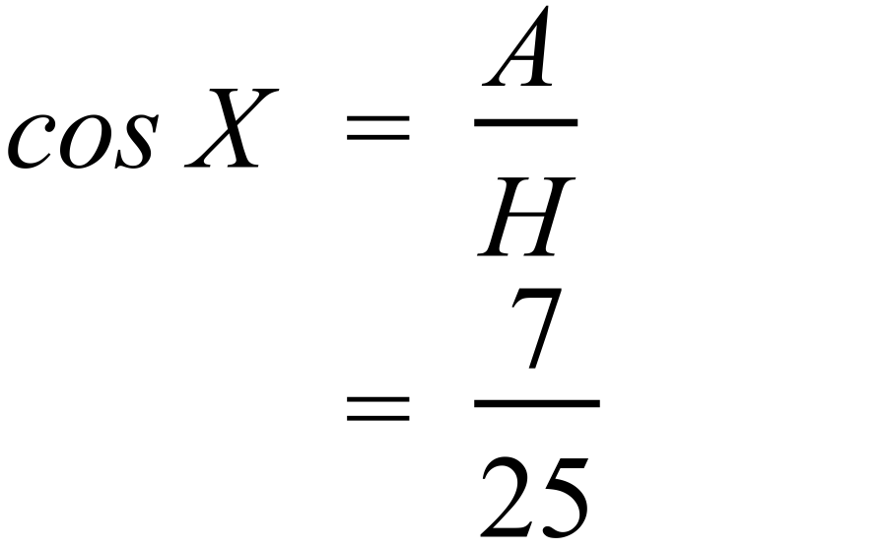 |  |  | A
 | 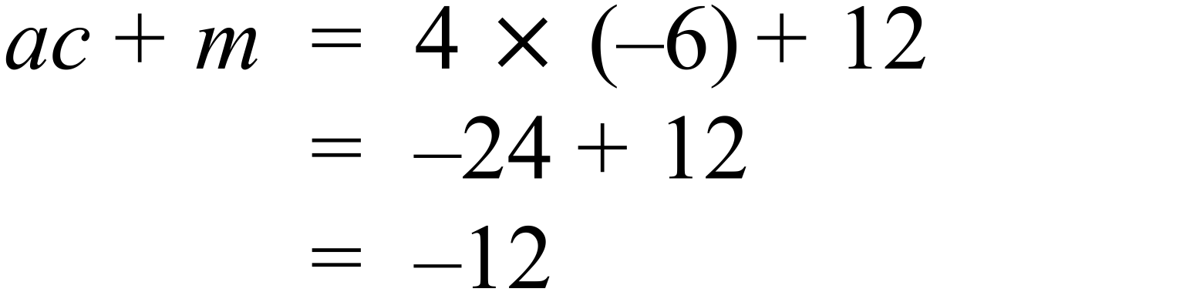 |  |  | A
 | 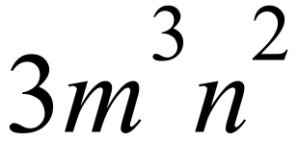 is not a factor of 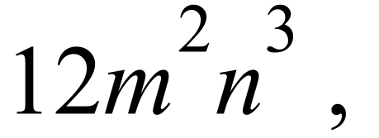as 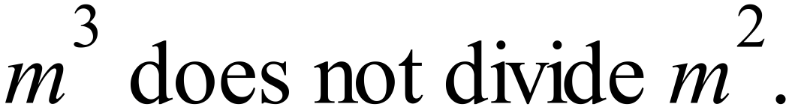 |  |  | C
 | 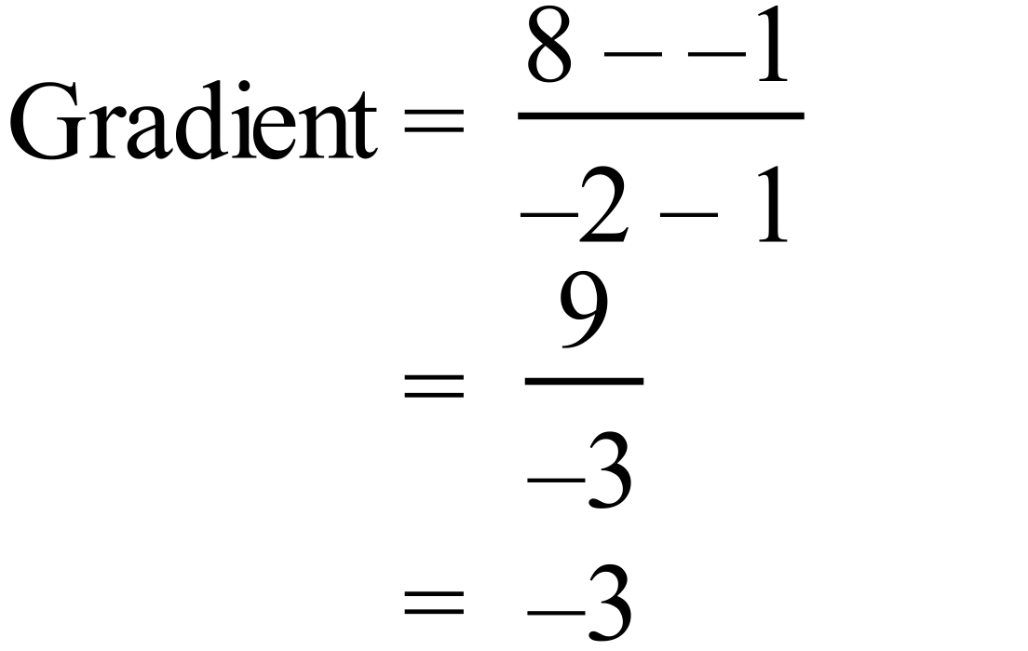 |  |  | C
 | 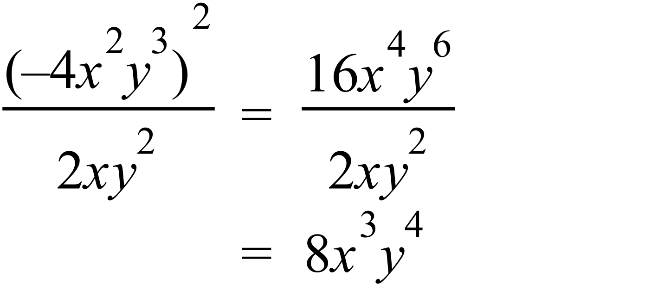 |  |  | D
 | 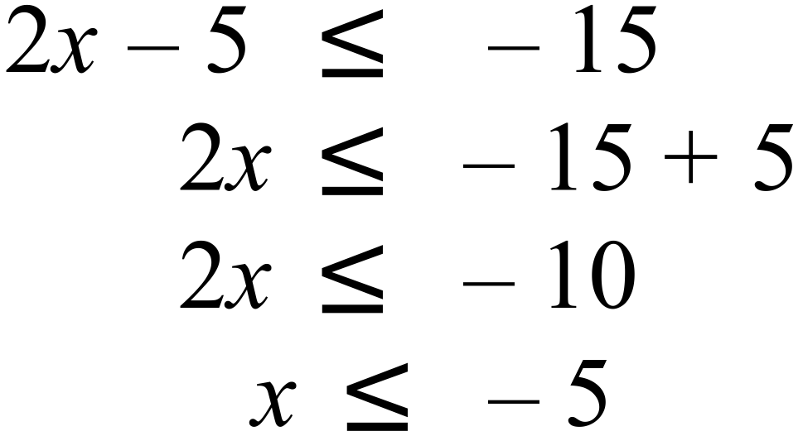 |  |  | D
 | They won 5 ( lost 2 and drew 1) |  |  | B
 | When they scored more than 15 points they won 5 games and drew 1, and when less than 15 points they won 1 and lost 2.  So B is incorrect as they did not win all games when they scored over 15 points. |  |  | B
 | Mean = 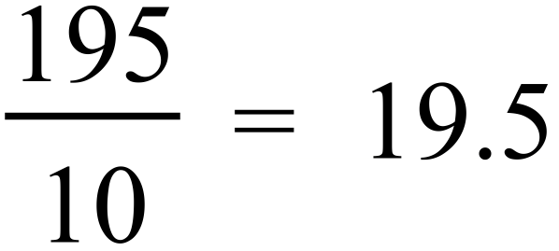 |  |  | C
 | Range = 20 – 10 = 10 |  |  | D
 | Sum of scores =  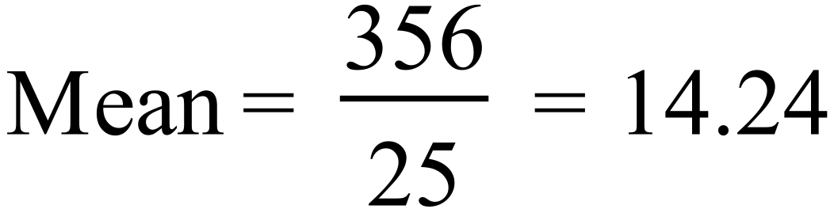 |  |  | D
 | 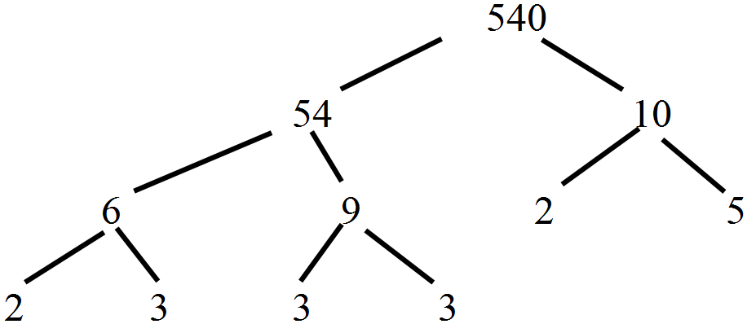  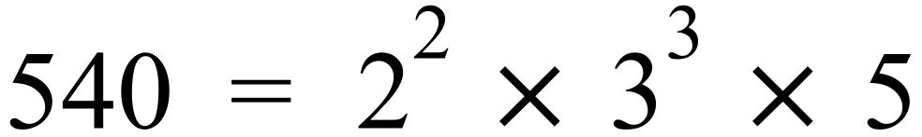 |  |  | A
 | Sales over $4000 = $2500.  Commission =  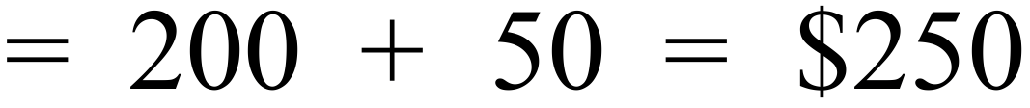  Pay for week = 700 + 250 = $950 |  |  | C
 | 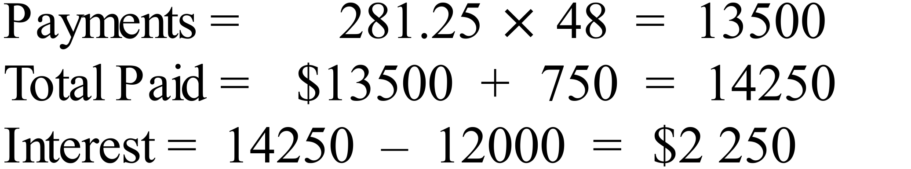 |  |  | D
 | 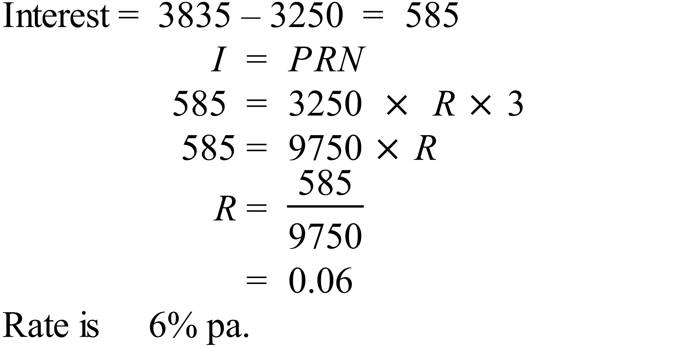 |  |  | B
 | 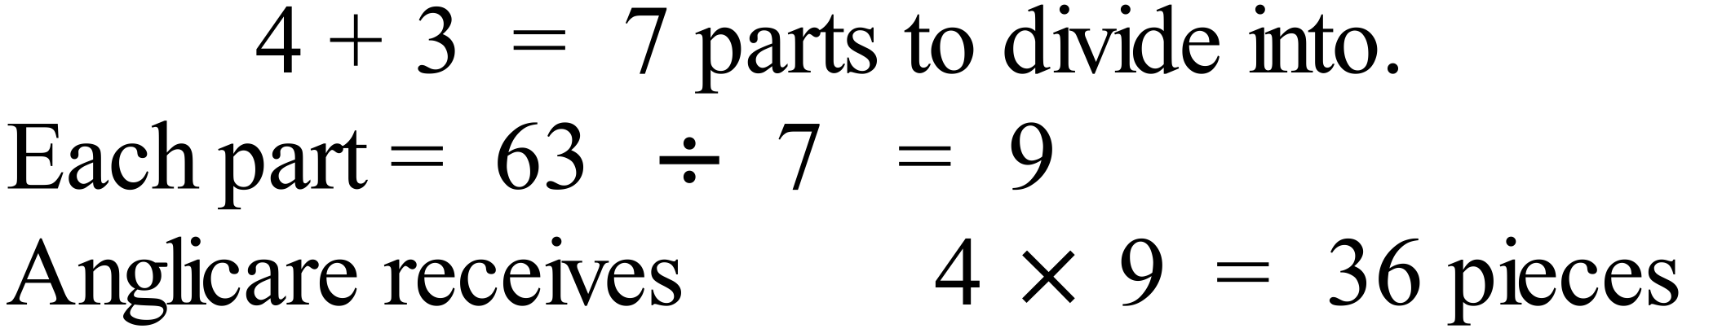 |  |  | D
 | 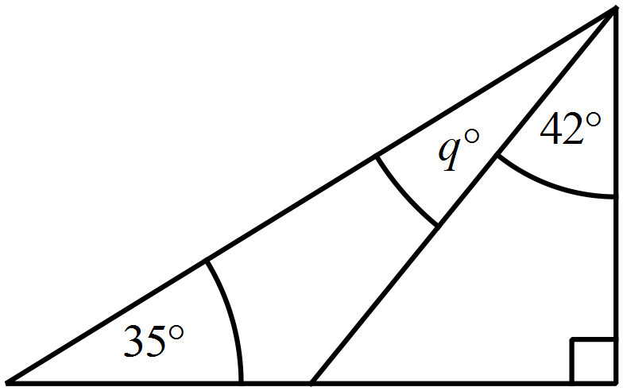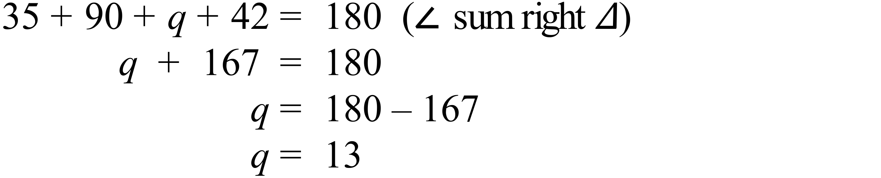 |  |  | A
 | 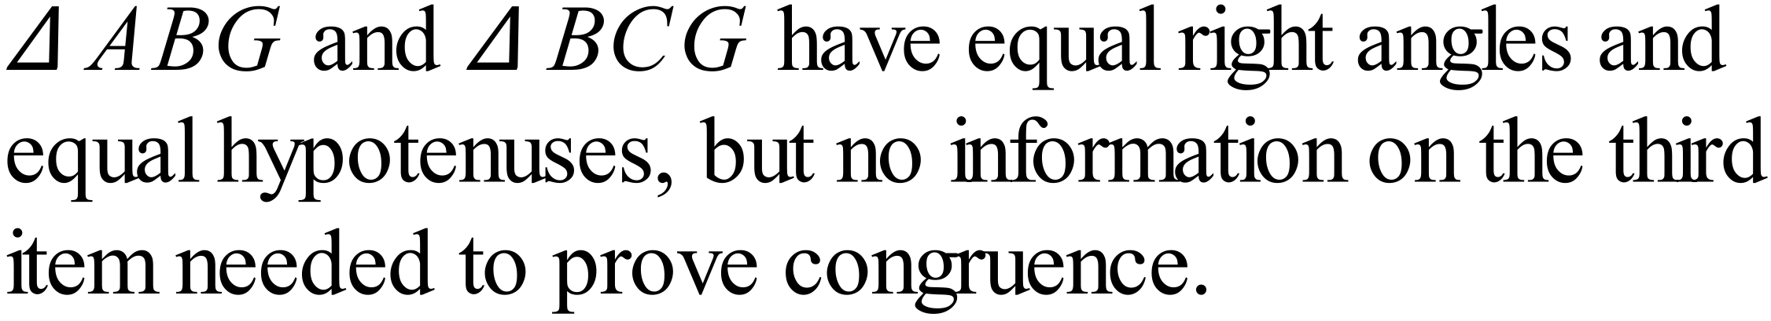 |  |  | B
 | Although a quadrilateral is present, it’s angle sum is not used in this proof. |  |  | B
 | 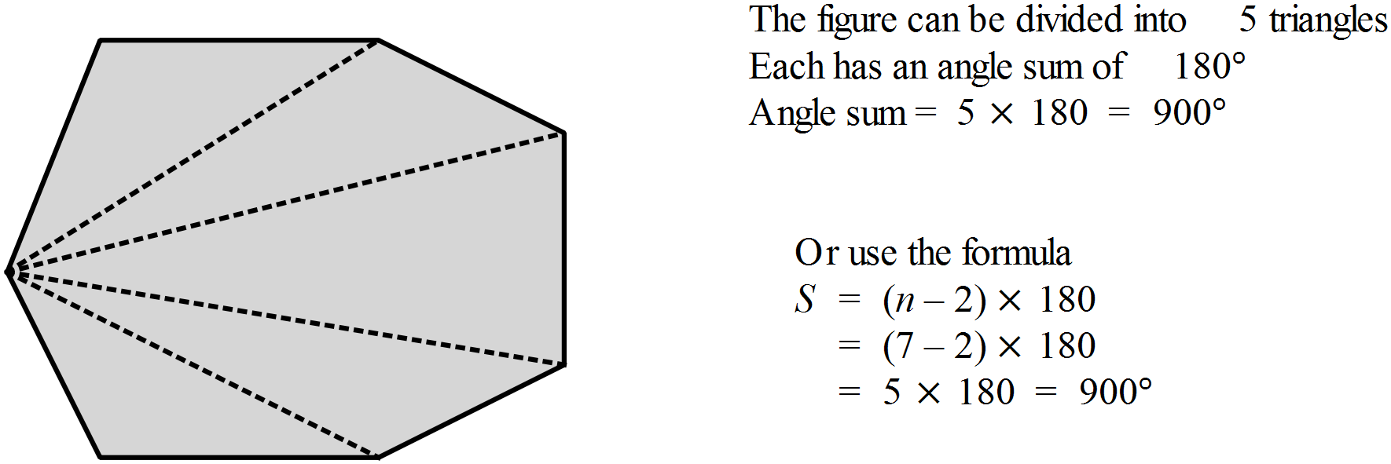 |  |  | C
 | 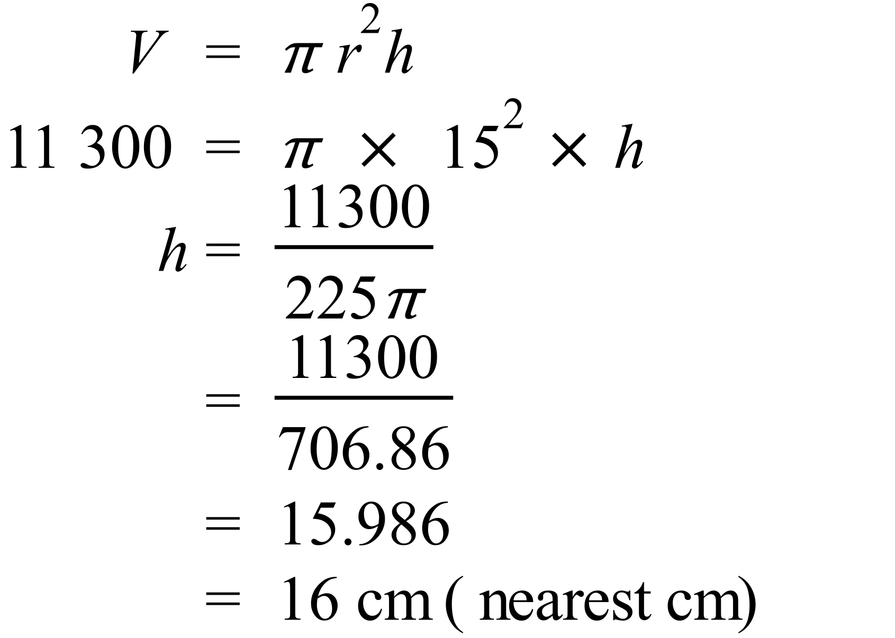 |  |  | C
 | 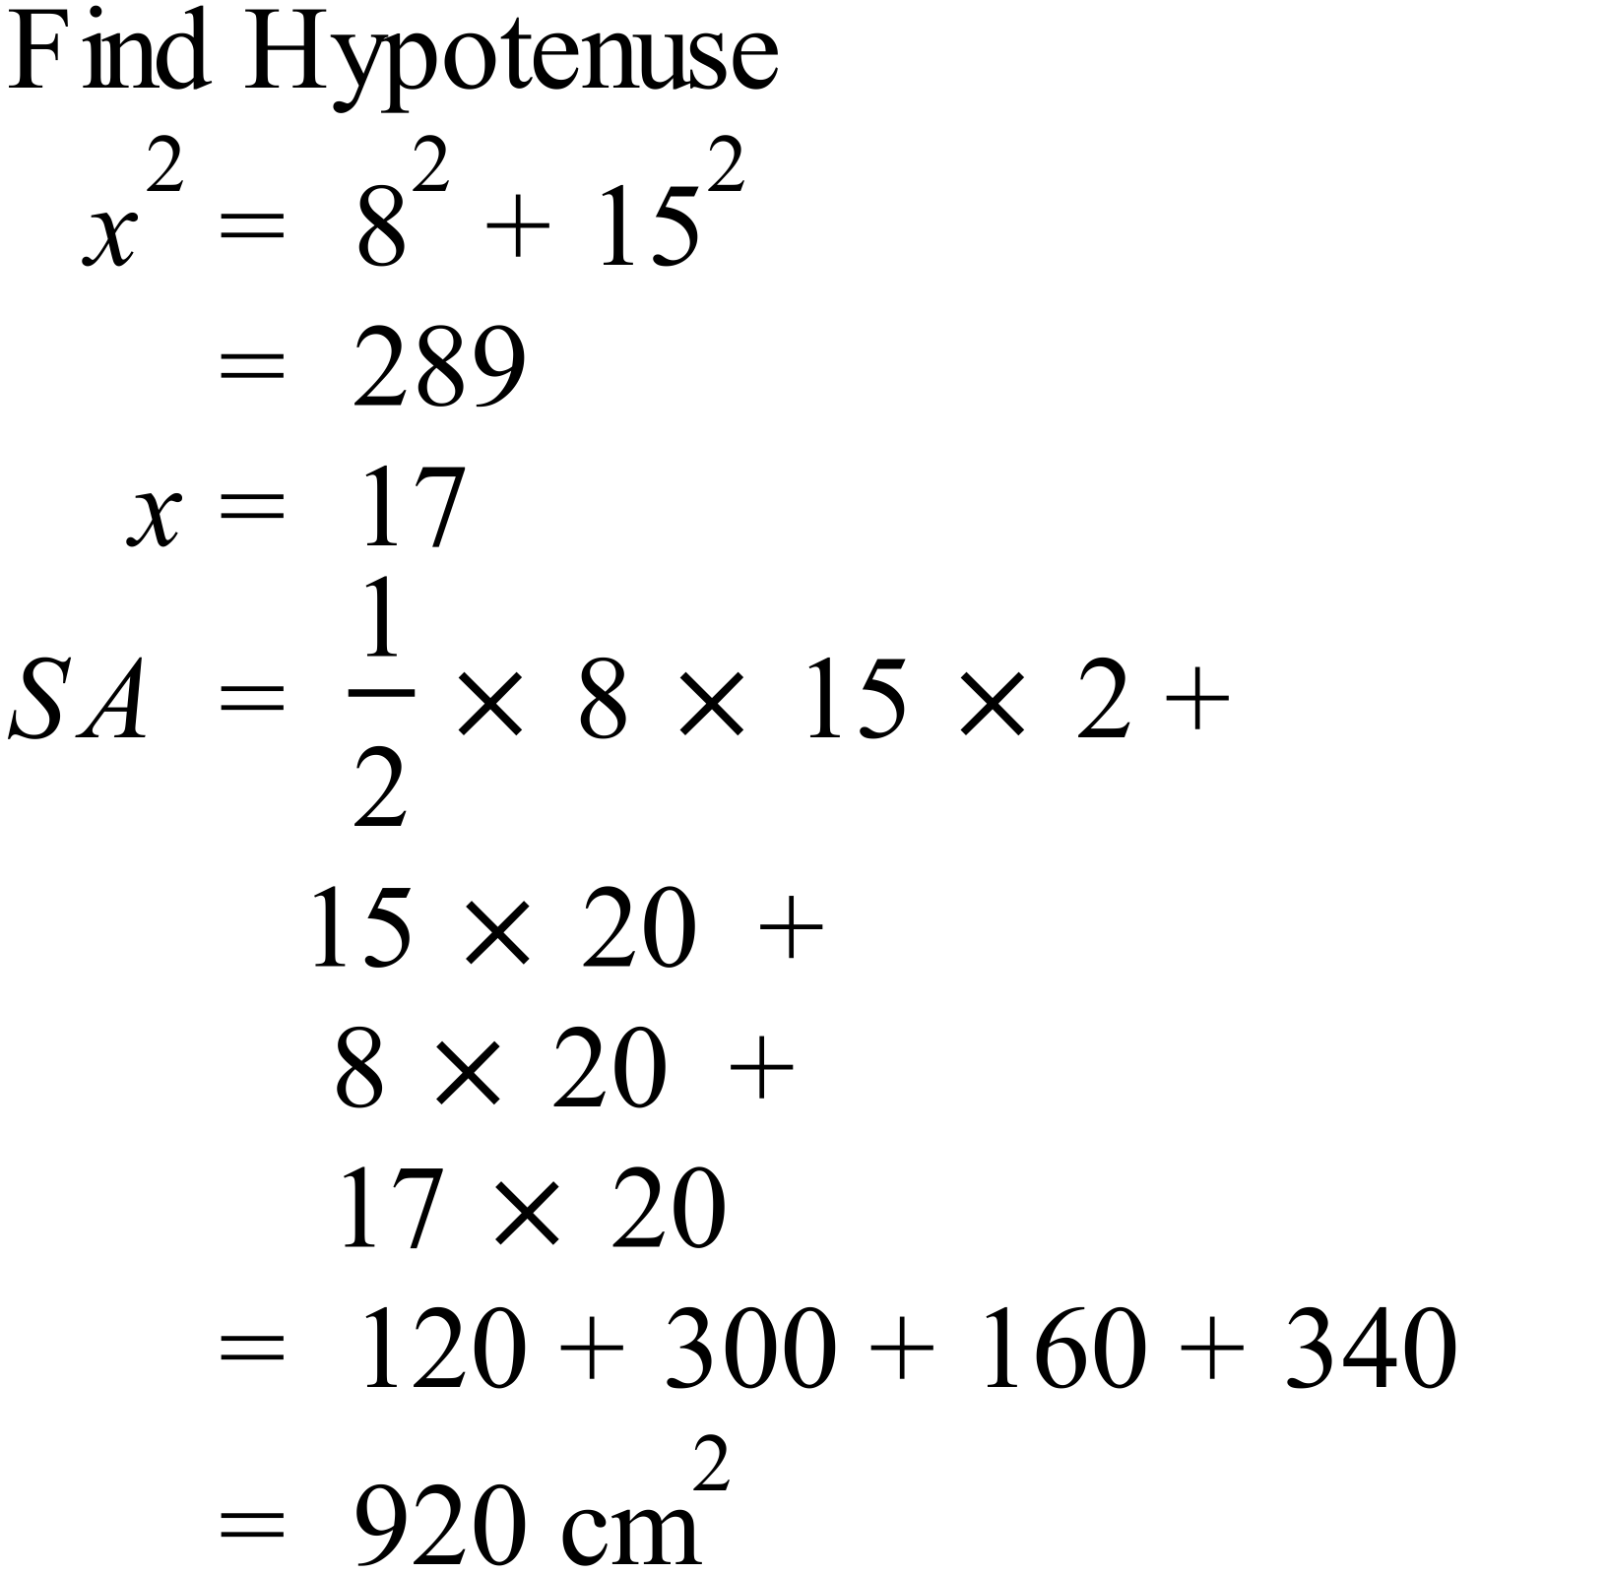 |  |  | D
 | 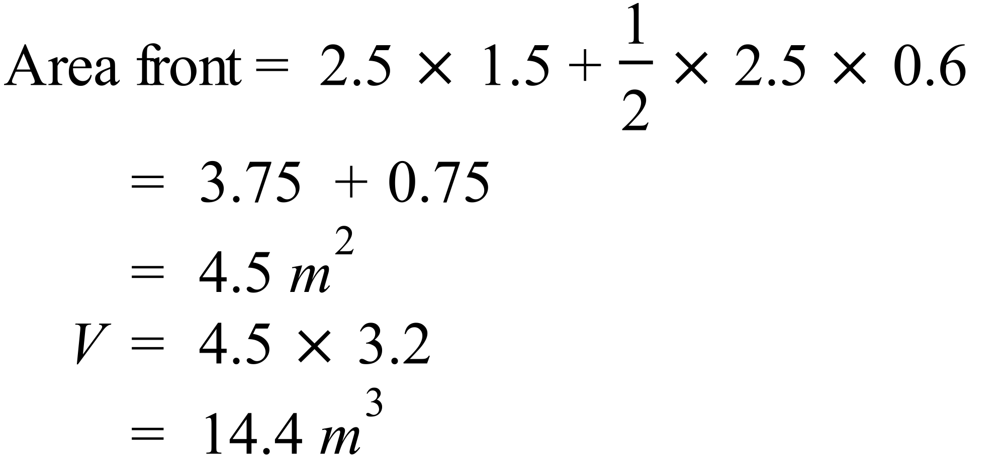 |  |  | C
 | 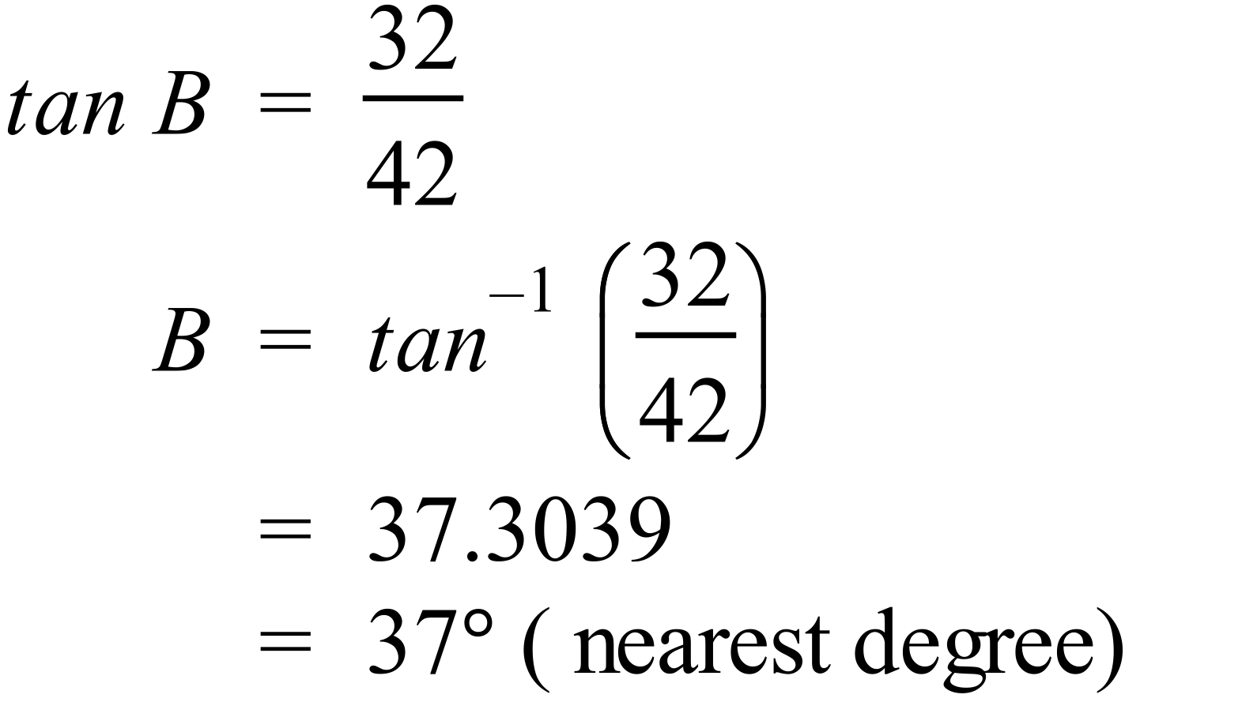 |  |  | A
 | 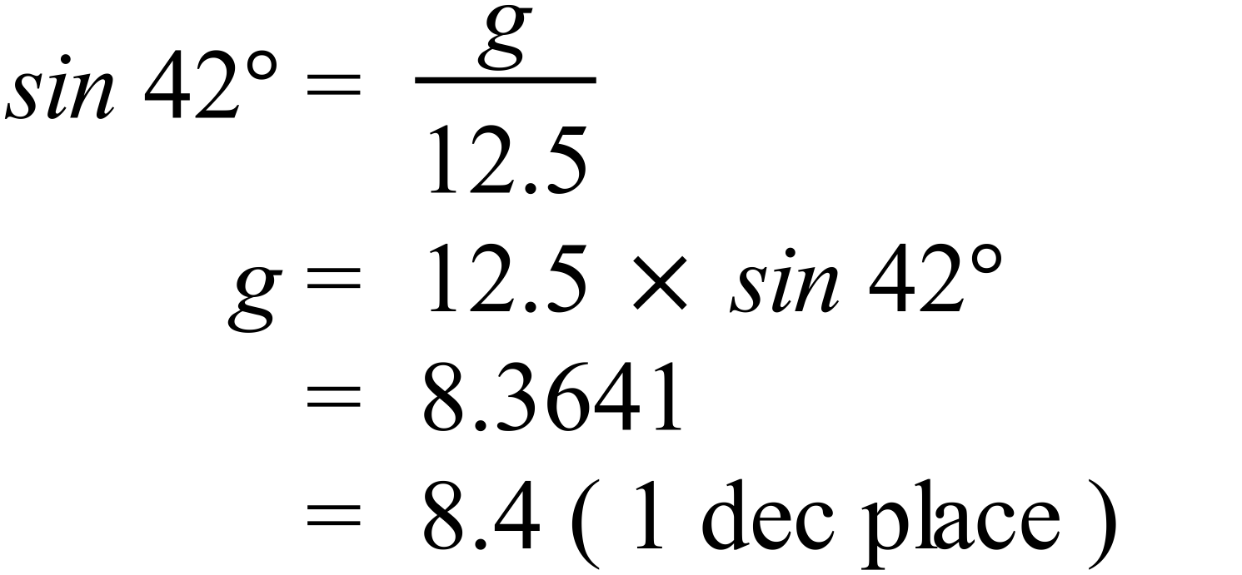 |  |  | A
 | 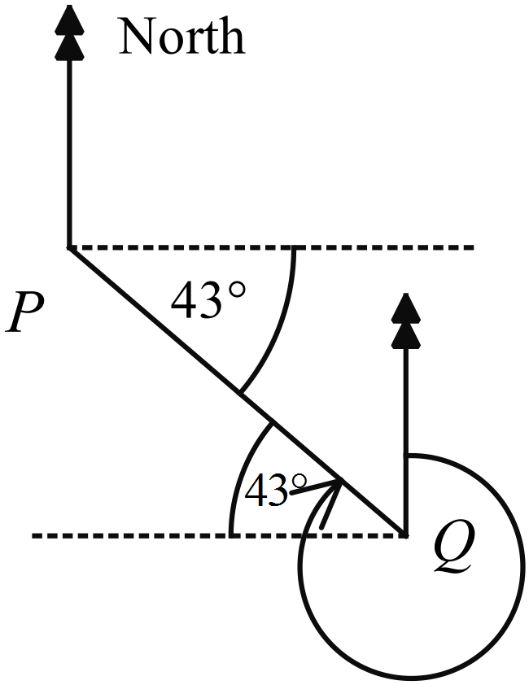Bearing of P from Q  is 270º + 43º = 313º |  |  | D
 | 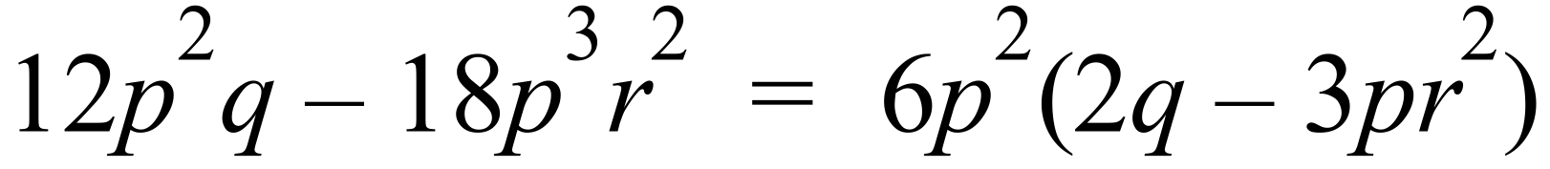 |  |  | D
 | 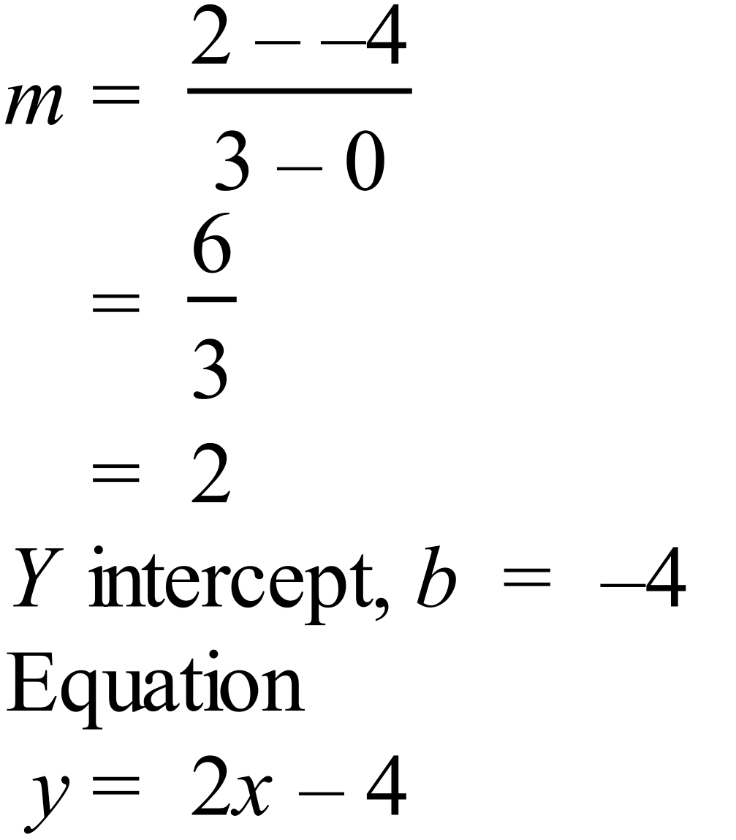 |  |  | C
 | 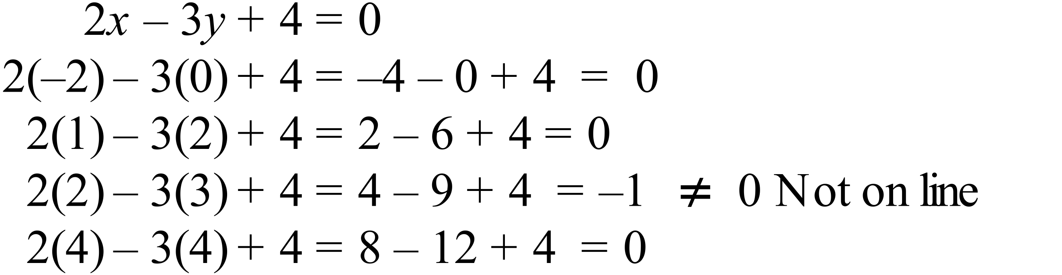 |  |  | C
 | 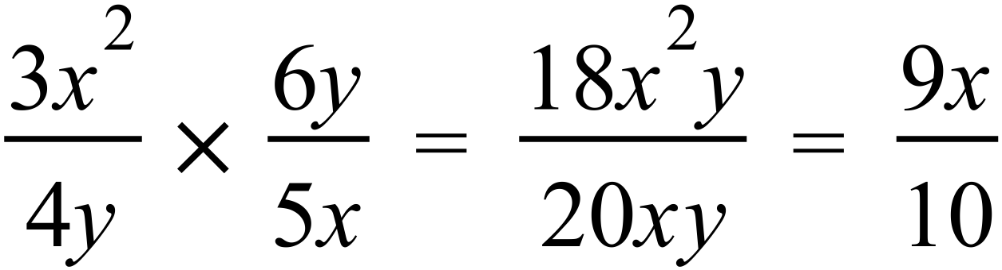 |  |  | B
 | 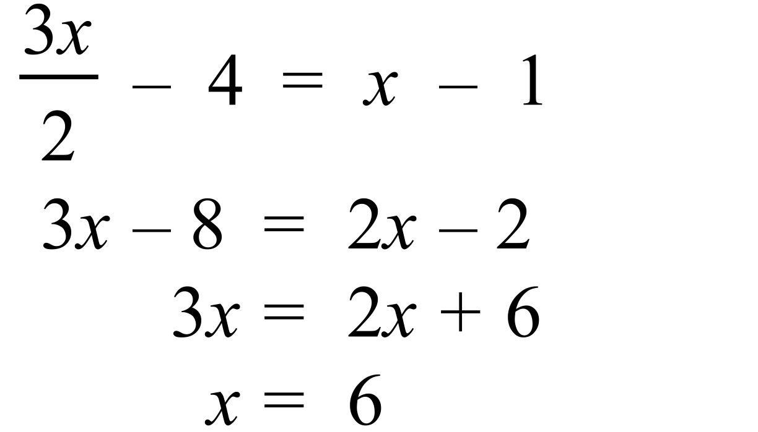 |  |  | B
 | Counting the leaves there are 21 scores.  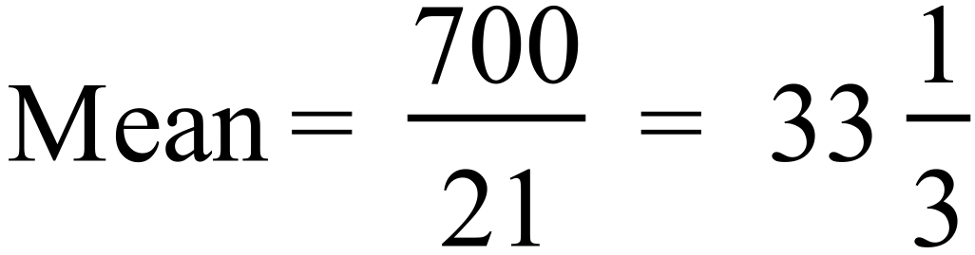 |  |  | B
 | Median is the middle number of 21 ( the 11th) which is 33. |  |  | A
   |  |  |  |  | 1 | 1 | 4 | 6
   |  |  |  |  | 2 | 2 | 5 | 6 | 7 | 8
   |  |  |  |  | 3 | 0 | 2 | 3 | 5 | 6 | 6 | 9
   |  |  |  |  | 4 | 2 | 4 | 7 | 9
   |  |  |  |  | 5 | 3 | 5
 | Middle of lower 10 scores is between 25 and 26 so 25.5  Middle of upper 10 scores is between 42 and 44 so 43  Interquartile range = 43 – 25.5 = 17.5 |  |  | A
   |  |  |  |  | 1 | 1 | 4 | 6
   |  |  |  |  | 2 | 2 | 5 | 6 | 7 | 8
   |  |  |  |  | 3 | 0 | 2 | 3 | 5 | 6 | 6 | 9
   |  |  |  |  | 4 | 2 | 4 | 7 | 9
   |  |  |  |  | 5 | 3 | 5
 | The distribution is bimodal and symmetrical. |  |  | A
 | As it is symmetrical the median and the mean are the same (at 23), as it is bimodal the mode is different (22 and 24), and the range of 6 is different again. |  |  | D

High School
Half Yearly Exam
Mathematics Course
Multiple Choice Section Answer Sheet
Name ________________________________ Teacher ________________________

Completely fill the response oval representing the most correct answer.

26. A B C D
27. A B C D
28. A B C D
29. A B C D
30. A B C D
31. A B C D
32. A B C D
33. A B C D
34. A B C D
35. A B C D
36. A B C D
37. A B C D
38. A B C D
39. A B C D
40. A B C D
41. A B C D
42. A B C D
43. A B C D
44. A B C D
45. A B C D
46. A B C D
47. A B C D
48. A B C D
49. A B C D
50. A B C D

51. A B C D
52. A B C D
53. A B C D
54. A B C D
55. A B C D
56. A B C D
57. A B C D
58. A B C D
59. A B C D
60. A B C D
61. A B C D
62. A B C D
63. A B C D
64. A B C D
65. A B C D
66. A B C D
67. A B C D
68. A B C D
69. A B C D
70. A B C D
71. A B C D
72. A B C D
73. A B C D
74. A B C D
75. A B C D

Year 10 |  | WME Half Yearly Maths | Calculator Allowed
Section 2 Part B Longer Answer Section
ANSWERS
 |  |  |  | Marks
76. | (a) Cost after discount = 80% of normal price.  = 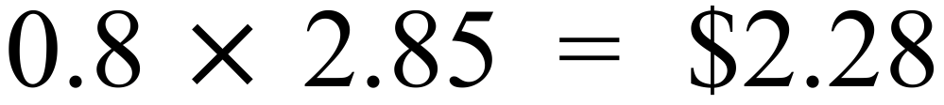 |  |  | 1 mark for correct answer
 | (b) Method of comparing by finding cost per kg.  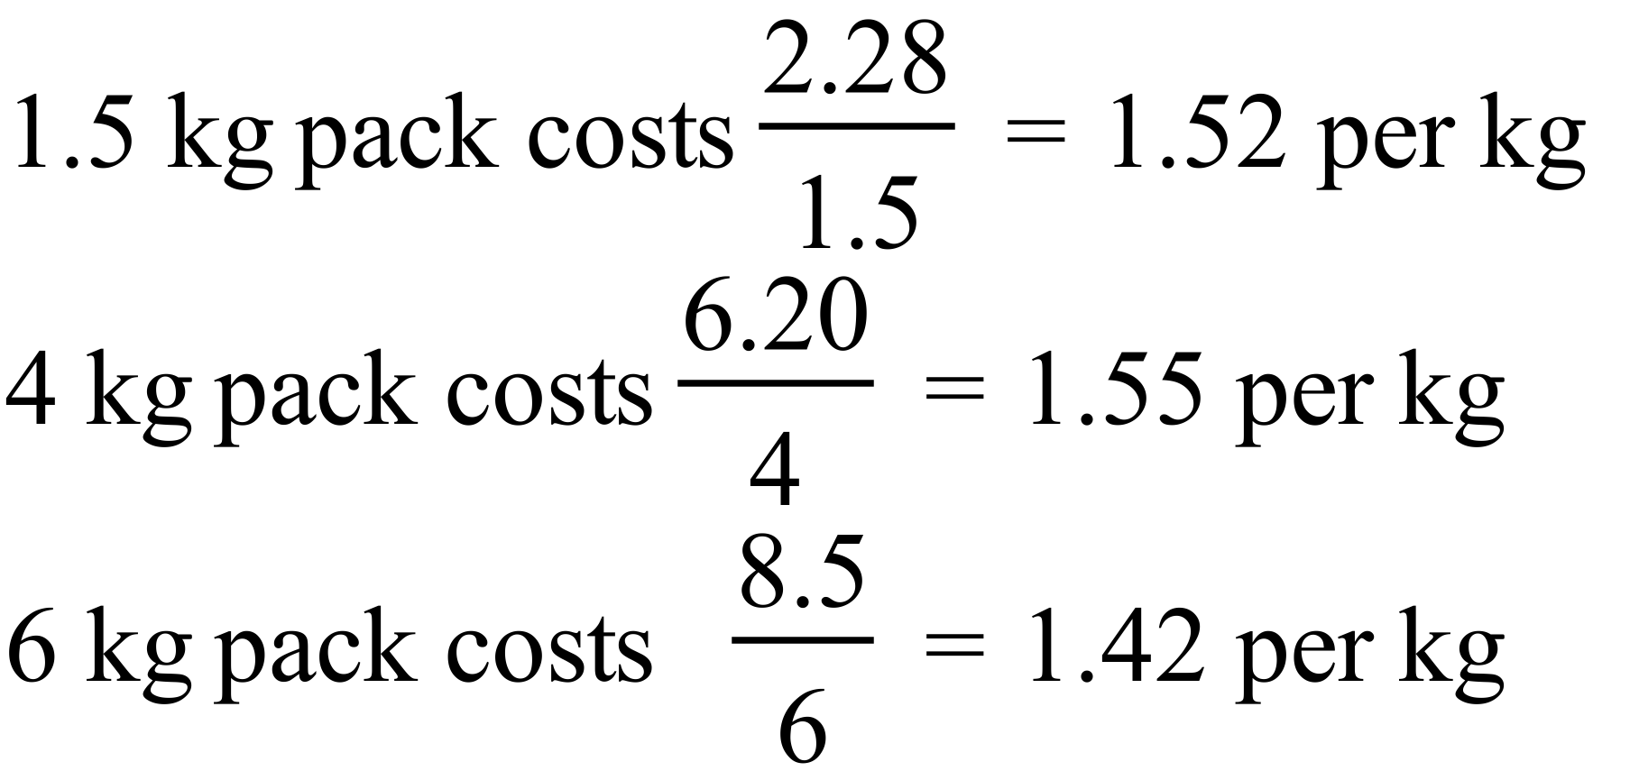  The 6 kg pack is the best value.  (Or convert all some common amount such as 12 kg.) |  |  | 2 marks for correct answer with working to justify answer  1 mark for wrong answer with some correct working relevant to answer
77. | 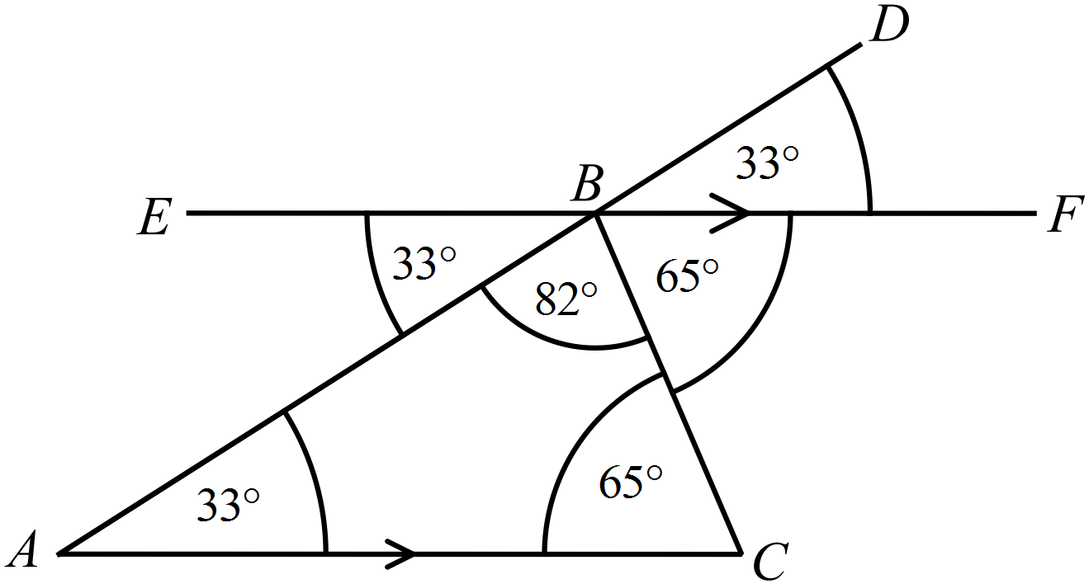(a)  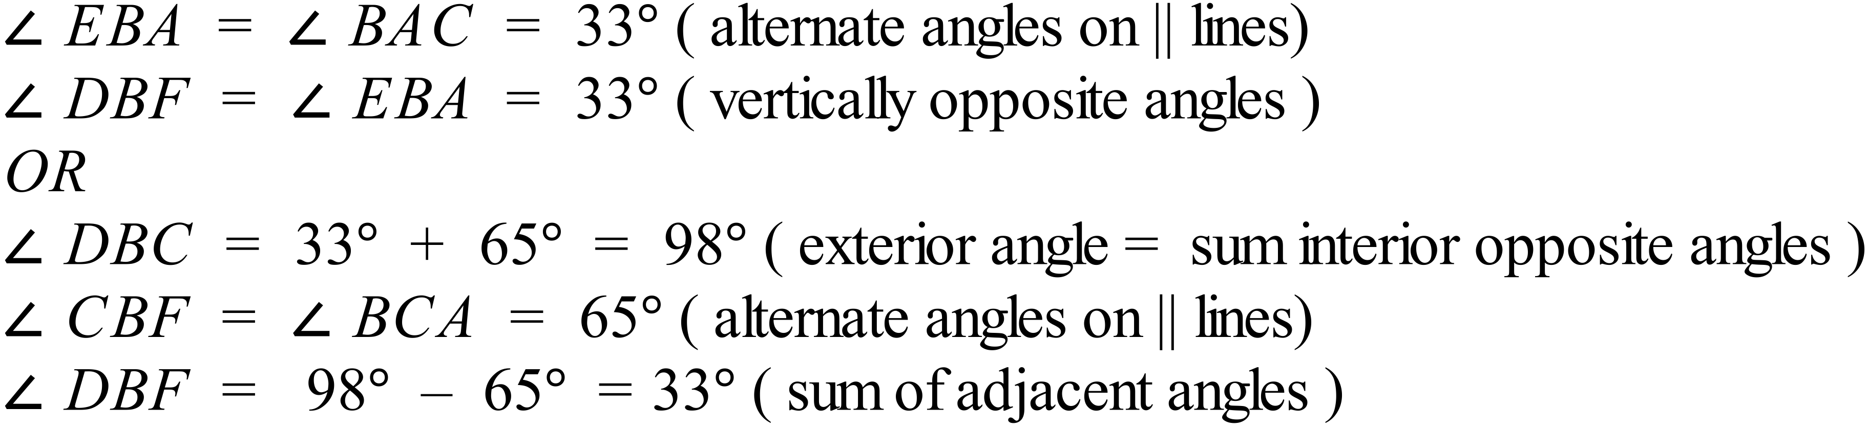 |  |  | 1 mark for an answer including basically correct reasoning.
 | (b) Depending on reasoning in part (a) may refer to results there.  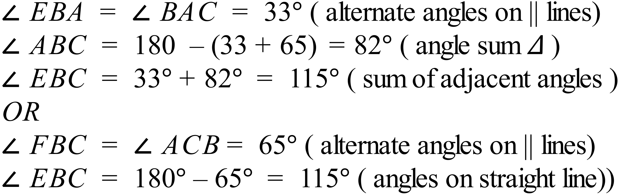 |  |  | 2 marks for any correct reasoning leading to conclusion of 33º.  1 mark for an answer including some correct reasoning
78. | (a) 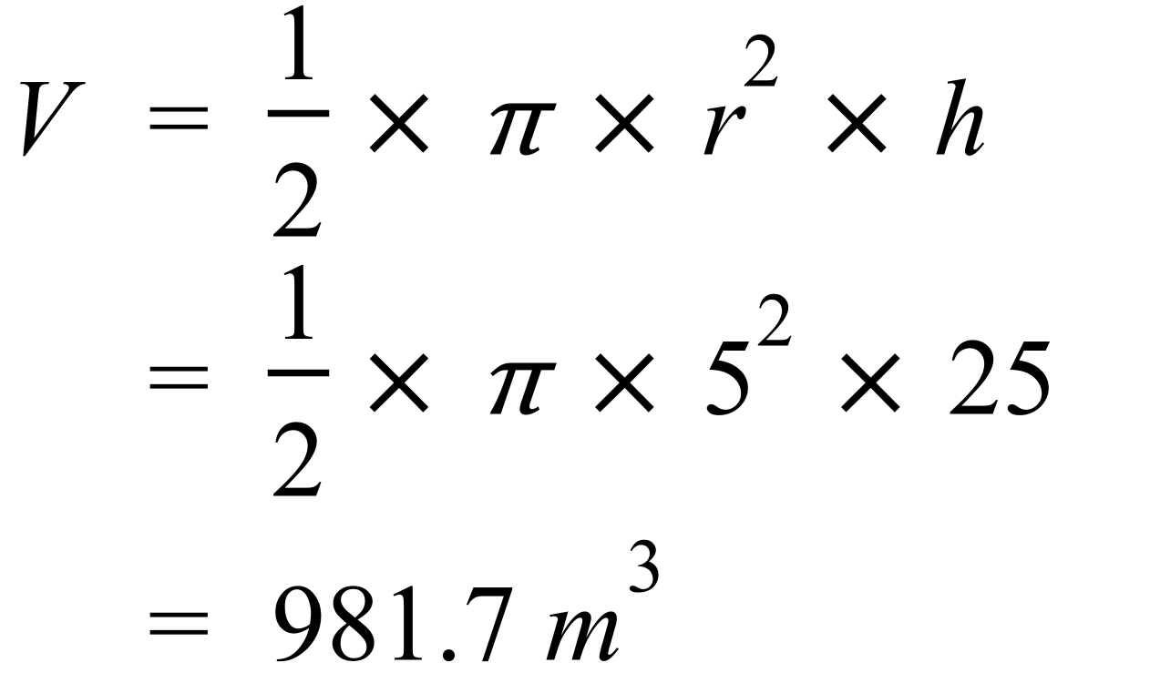 |  |  | 1 mark for correct answer
 | (b) 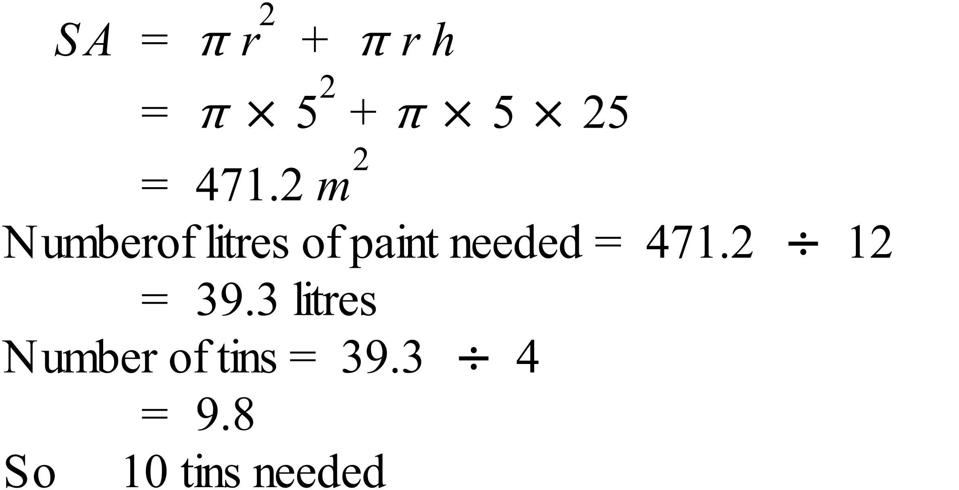 |  |  | 2 marks for correct answer including area and number of tins.  1 mark for an answer with an error in either calculation of area or number of tins
79. | (a) 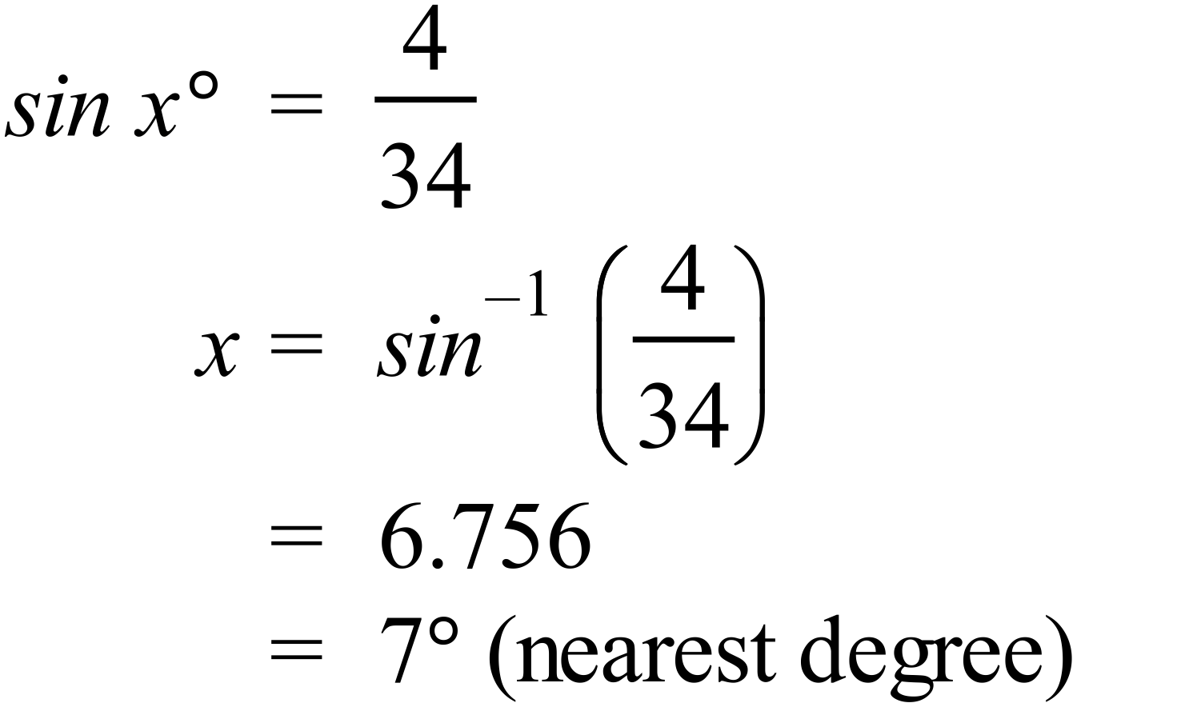 |  |  | 1 mark for correct answer
 | (b) 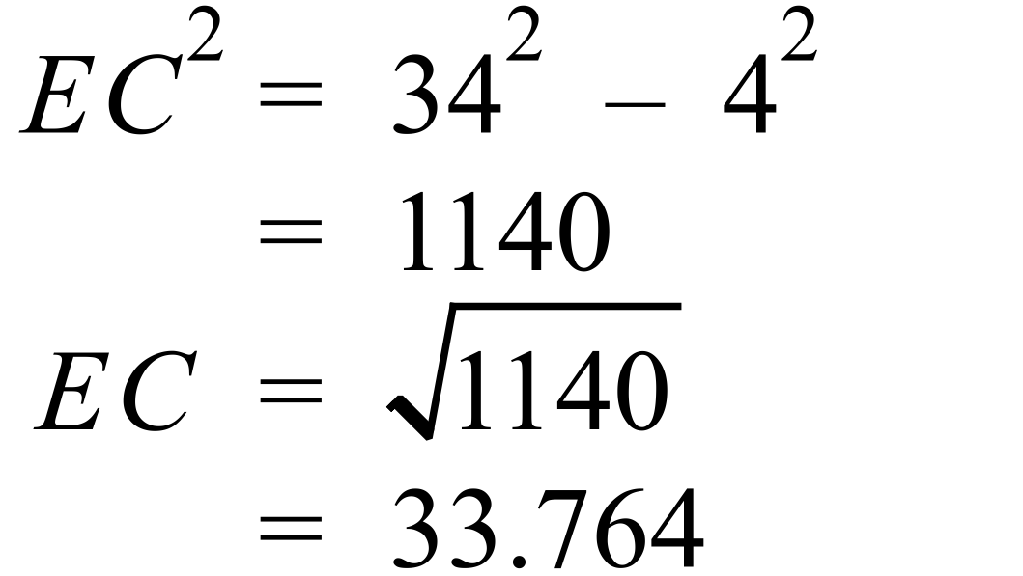  Or by using the angle found in (a) |  |  | 1 mark for correct answer
 | (c) DF = 16+4 = 20  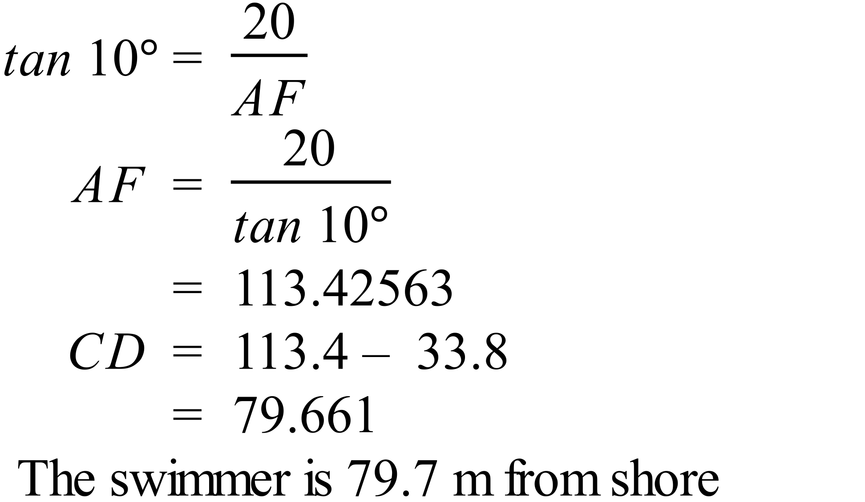 |  |  | 2 marks for correct answer  1 mark for an answer with an error in either calculation of AF or of CD
80. | (a) Number of romances = 200 – (35+15+40) = 30  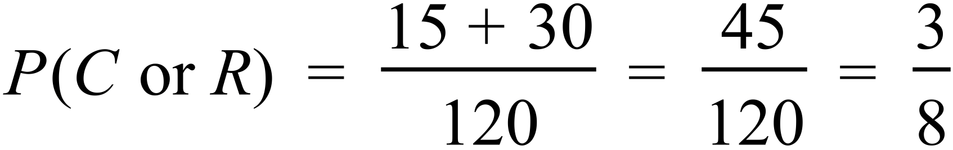 |  |  | 1 mark for correct answer
 | (b) 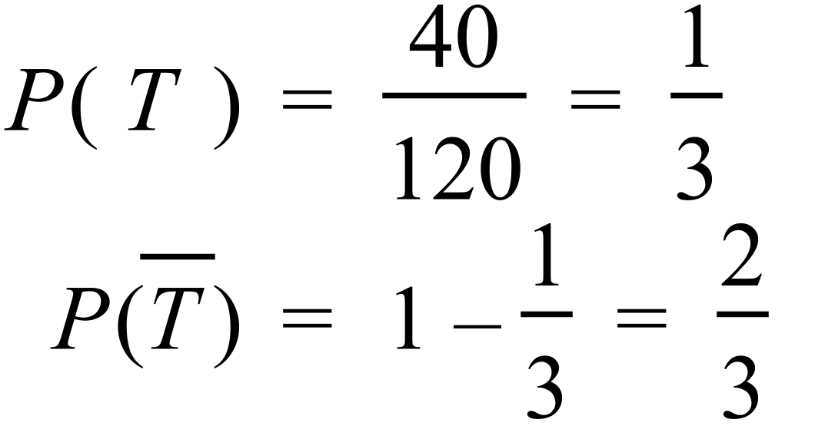 |  |  | 1 mark for correct answer
81. | (a) 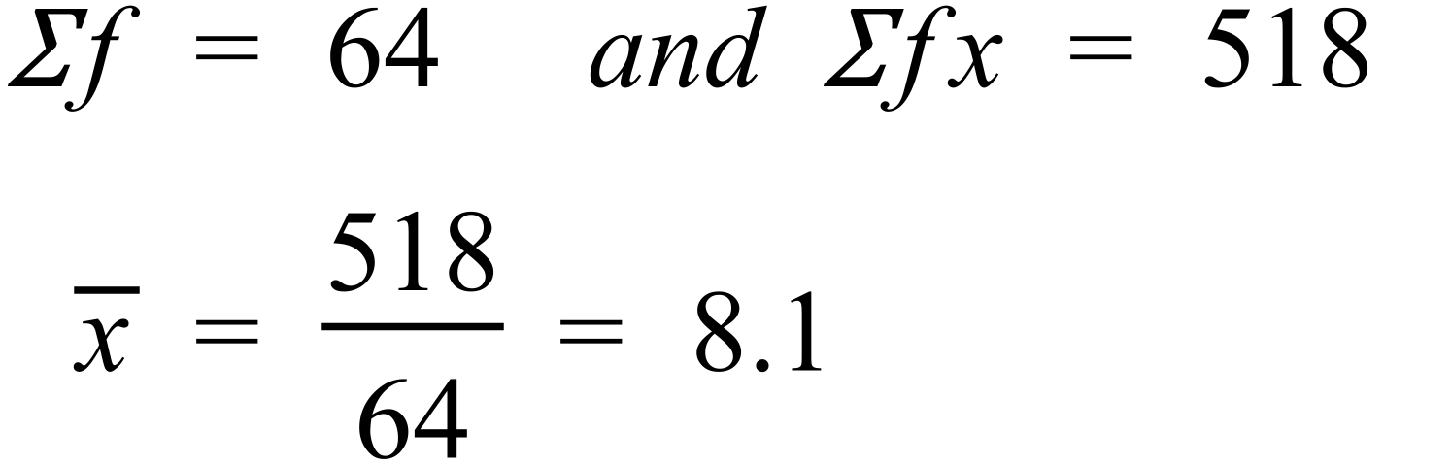 |  |  | 1 mark for correct answer
 | (b) Median from 64 scores is between 32nd and 33rd scores.  Both of these are 8’s so median = 8. |  |  | 1 mark for correct answer
 | (c) The higher frequencies are toward the higher scores, so the distribution is negatively skewed. |  |  | 1 mark for correct answer
82. | (a) 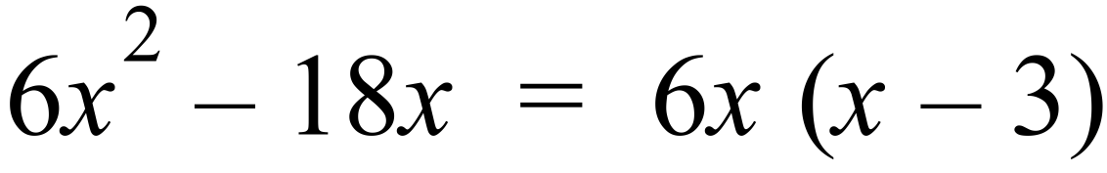 |  |  | 1 mark for correct answer
 | (b) 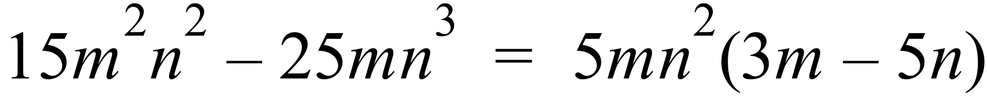 |  |  | 1 mark for correct answer
83. | 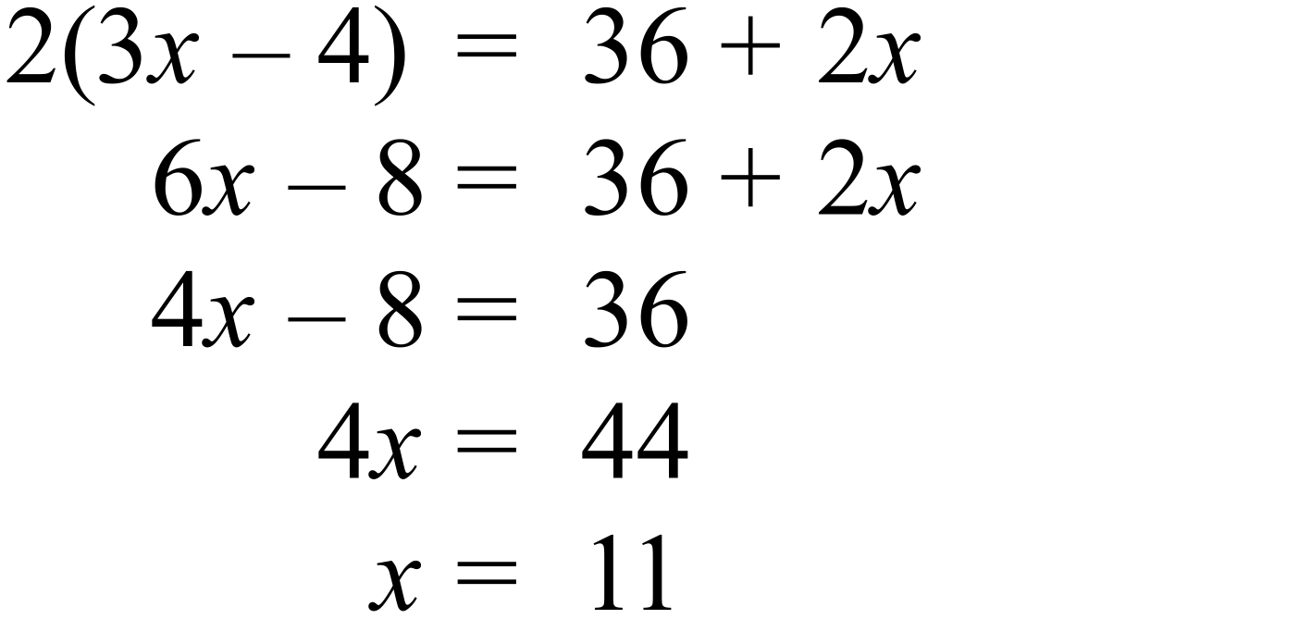 |  |  | 2 marks for correct answer .  1 mark for an answer with a minor error in calculation or logic.
84. | 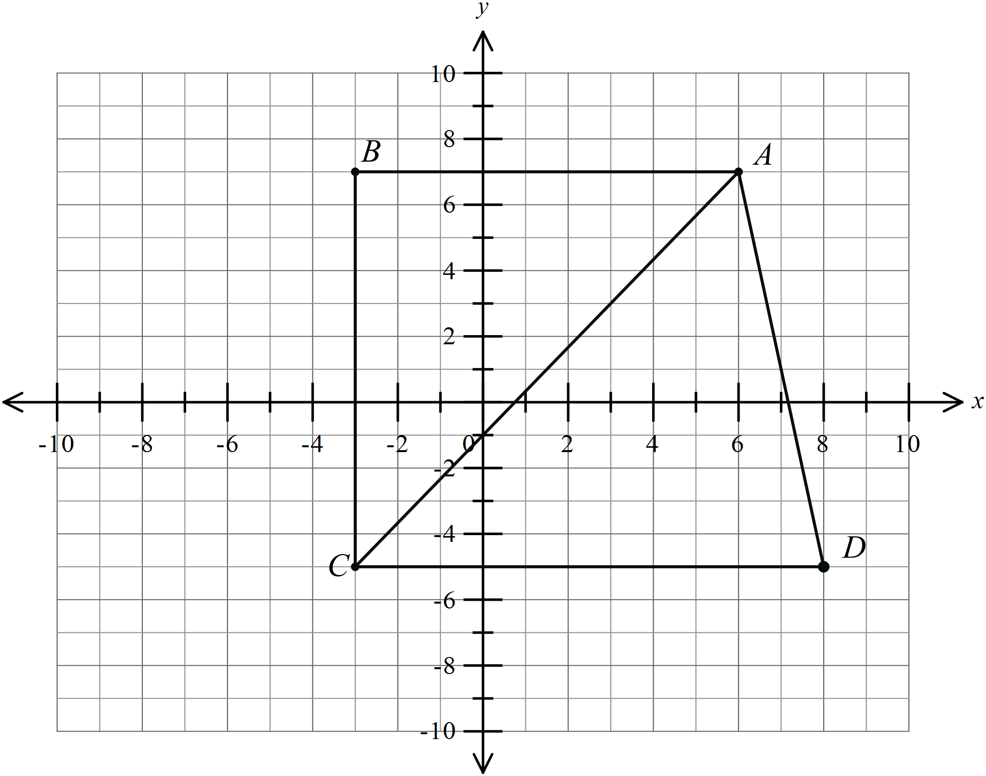(a) Mark Points B and D as shown. |  |  | 1 mark for 2 points, can award ½ for each if you wish.
 | (b) The quadrilateral is joined and found to be a trapezium.  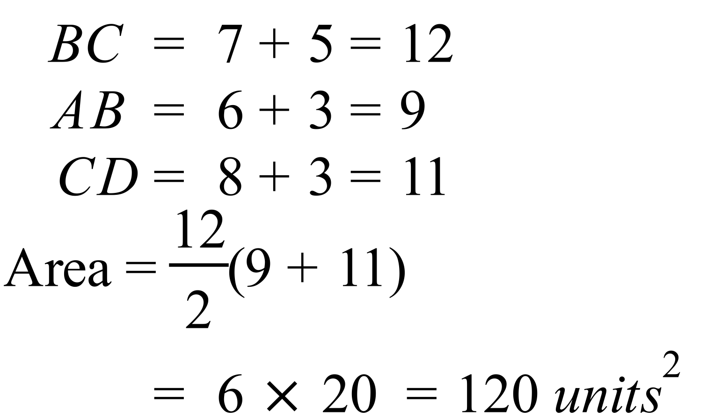 |  |  | 1 mark for correct answer
 | (c) Using the triangle ABC which is right angled, or by the formula.  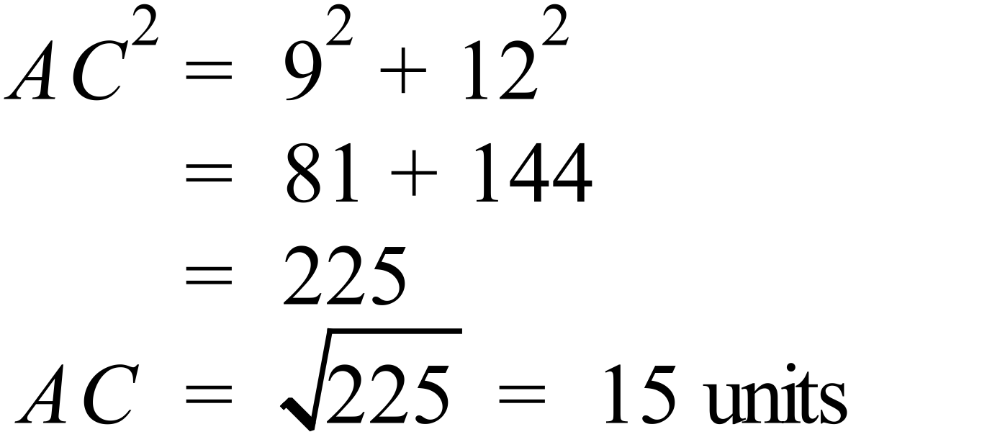 |  |  | 1 mark for correct answer

